NSW Education Standards Authority | 
Mathematics K–10 (2022)
curriculum.nsw.edu.au
Generated Oct 2025
Downloaded October 2025
© 2025 NSW Education Standards Authority
NESA acknowledges Traditional Owners and Custodians of Country throughout NSW, and pays respect to Elders past and present. NESA recognises Aboriginal Peoples’ continuing Cultures and Connections to lands, waters, skies and Community.
The documents on the NSW Education Standards Authority (NESA) website and the NSW Curriculum website contain material prepared by NESA for and on behalf of the Crown in right of the State of New South Wales. The material is protected by Crown copyright.
These websites hold the only official and up-to-date versions of the documents available on the internet. Any other copies of these documents, or parts of these documents, that may be found elsewhere on the internet might not be current and are not authorised. You cannot rely on copies from any other source.
All rights are reserved. No part of the material may be:
- reproduced in Australia or in any other country by any process, electronic or otherwise, in any material form
- transmitted to any other person or stored electronically in any form without the written permission of NESA except as permitted by the Copyright Act 1968 (Cth).
When you access the material, you agree:
- to use the material for research or study, criticism or review, reporting news and parody or satire
- to use the material for information purposes only
- not to modify the material or any part of the material without the written permission of NESA
- to reproduce a single copy for personal bona fide study use only and not to reproduce any major extract or the entire material without the permission of NESA
- to include this copyright notice in any copy made
- to acknowledge that NESA is the source of the material.
The documents may include third-party copyright material such as photos, diagrams, quotations, cartoons and artworks. This material is protected by Australian and international copyright laws and may not be reproduced or transmitted in any format without the copyright owner’s permission. Unauthorised reproduction, transmission or commercial use of such copyright material may result in prosecution.
NESA has made all reasonable attempts to locate the owners of third-party copyright material. NESA invites anyone from whom permission has not been sought to contact the Copyright Officer.
Special arrangements applying to the NSW Curriculum Reform
As part of the NSW Curriculum Reform process, NESA grants a limited non-exclusive licence to:
- teachers employed in NSW government schools and registered non-government schools
- representatives from peak school education bodies, such as the NSW Department of Education, Catholic Schools NSW, the Association of Independent Schools of NSW and TAFE NSW
- parents of children registered for home schooling
to use, modify and adapt the NSW syllabuses for non-commercial educational use only. The adaptation must not have the effect of bringing NESA into disrepute.
Note: The above arrangements do not apply to private/home tutoring companies, professional learning service providers, publishers, and other organisations.
For more information on the above or for commercial use or any other purpose, please contact the Copyright Officer for permission.
Email: copyright@nesa.nsw.edu.au

Table of contents
Table of contents 4
Mathematics K–10 (2022) 5
K–2 Implementation survey 5
Overview 5
Syllabus overview 5
Rationale 12
Aim 13
Table of outcomes 14
Secondary (7–10) 14
Outcomes and content for Stage 4 20
Computation with integers 20
Fractions, decimals and percentages 23
Ratios and rates 31
Algebraic techniques 34
Indices 38
Equations 41
Linear relationships 44
Length 48
Right-angled triangles (Pythagoras’ theorem) 51
Area 53
Volume 59
Angle relationships 61
Properties of geometrical figures 67
Data classification and visualisation 71
Data analysis 75
Probability 78
Assessment 80
Common Grade Scale 80
Course performance descriptors 80
Assessment of Life Skills outcomes 81

Mathematics K–10 (2022)

K–2 Implementation survey
Provide feedback on the implementation of the Mathematics syllabus for K–2.
The Mathematics K–10 Syllabus (2022): K–2 Implementation survey will run from 8 September – 19 December 2025.
Implementation from 2024
The new Mathematics K–10 Syllabus (2022) is to be implemented from 2024 and replaces the Mathematics K–10 Syllabus (2012).
School sectors are responsible for implementing syllabuses and are best placed to provide schools with specific guidance and information on implementation given their understanding of their individual contexts.

Overview

Syllabus overview

Organisation of Mathematics K–10
The syllabus structure illustrates the important role Working mathematically plays across all areas of mathematics and reflects the strengthened connections between concepts. Working mathematically has been embedded in the outcomes, content and examples of the syllabus.
Mathematics K–10 outcomes and their related content are organised in:
- Number and algebra
- Measurement and space
- Statistics and probability

Working mathematically
The Working mathematically processes present in the Mathematics K–10 syllabus are:
- communicating
- understanding and fluency
- reasoning
- problem solving.
Students learn to work mathematically by using these processes in an interconnected way. The coordinated development of these processes results in students becoming mathematically proficient.
When students are Working mathematically it is important to help them to reflect on how they have used their thinking to solve problems. This assists students to develop ‘mathematical habits of mind’ (Cuoco et al. 2010).
Students need many experiences that require them to relate their knowledge to the vocabulary and conceptual frameworks of mathematics.

Overarching Working mathematically outcome
To highlight how these processes are interrelated, in Mathematics K–10 there is one overarching Working mathematically outcome.
A student develops understanding and fluency in mathematics through:
- exploring and connecting mathematical concepts
- choosing and applying mathematical techniques to solve problems
- communicating their thinking and reasoning coherently and clearly.
The Working mathematically outcome describes the thinking and doing of mathematics. In doing so, the outcome indicates the breadth of mathematical actions that teachers need to emphasise. The overarching Working mathematically outcome is the same across the K–10 Mathematics syllabus.
The Working mathematically processes should be embedded within the concepts being taught. Embedding Working mathematically ensures students are able to fluently understand concepts and make connections to other focus areas. The mathematics focus area outcomes and content provide the knowledge and skills for students to 'reason about', and contexts for problem solving. The overarching Working mathematically outcome is assessed in conjunction with the mathematics content outcomes. The sophistication of Working mathematically processes develops through each stage of learning and can be observed in relation to the increase in complexity of the mathematics outcomes and content. A student's level of competence in Working mathematically can be monitored over time, for example, within Additive Relations by the choice of strategy appropriate to the task, and the use of efficient strategy for the stage of learning the student is working at.
Further information is available in Elaborating on Working mathematically in K–10 (Word, 5 pages, 914.28 kB).
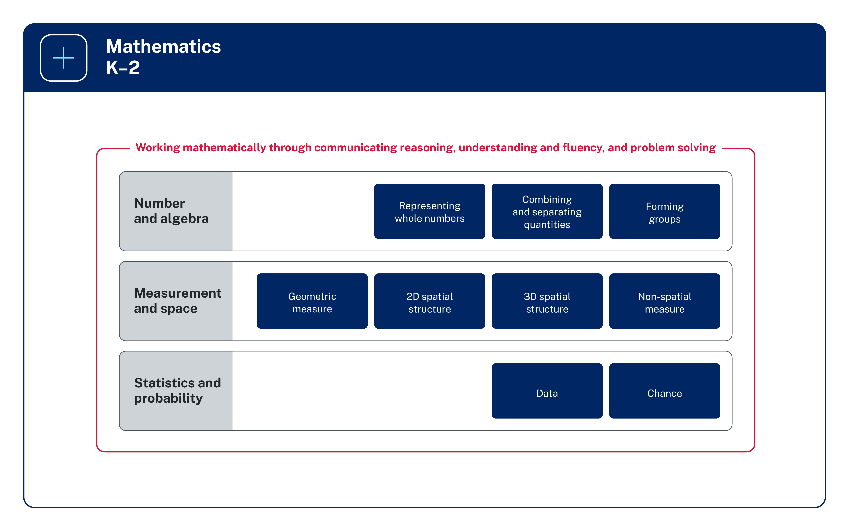
Figure 1: The organisation of Mathematics K–2

Image long description: An overview of the syllabus structure for Early Stage 1 and Stage 1 in Mathematics across the 3 areas of Number and algebra, Measurement and space, and Statistics and probability. Number and algebra reads horizontally across Representing whole numbers, Combining and separating quantities, and Forming groups. Measurement and space reads horizontally across Geometric measure, 2D spatial structure, 3D spatial structure, and Non-spatial measure. Statistics and probability reads horizontally across Data and Chance.
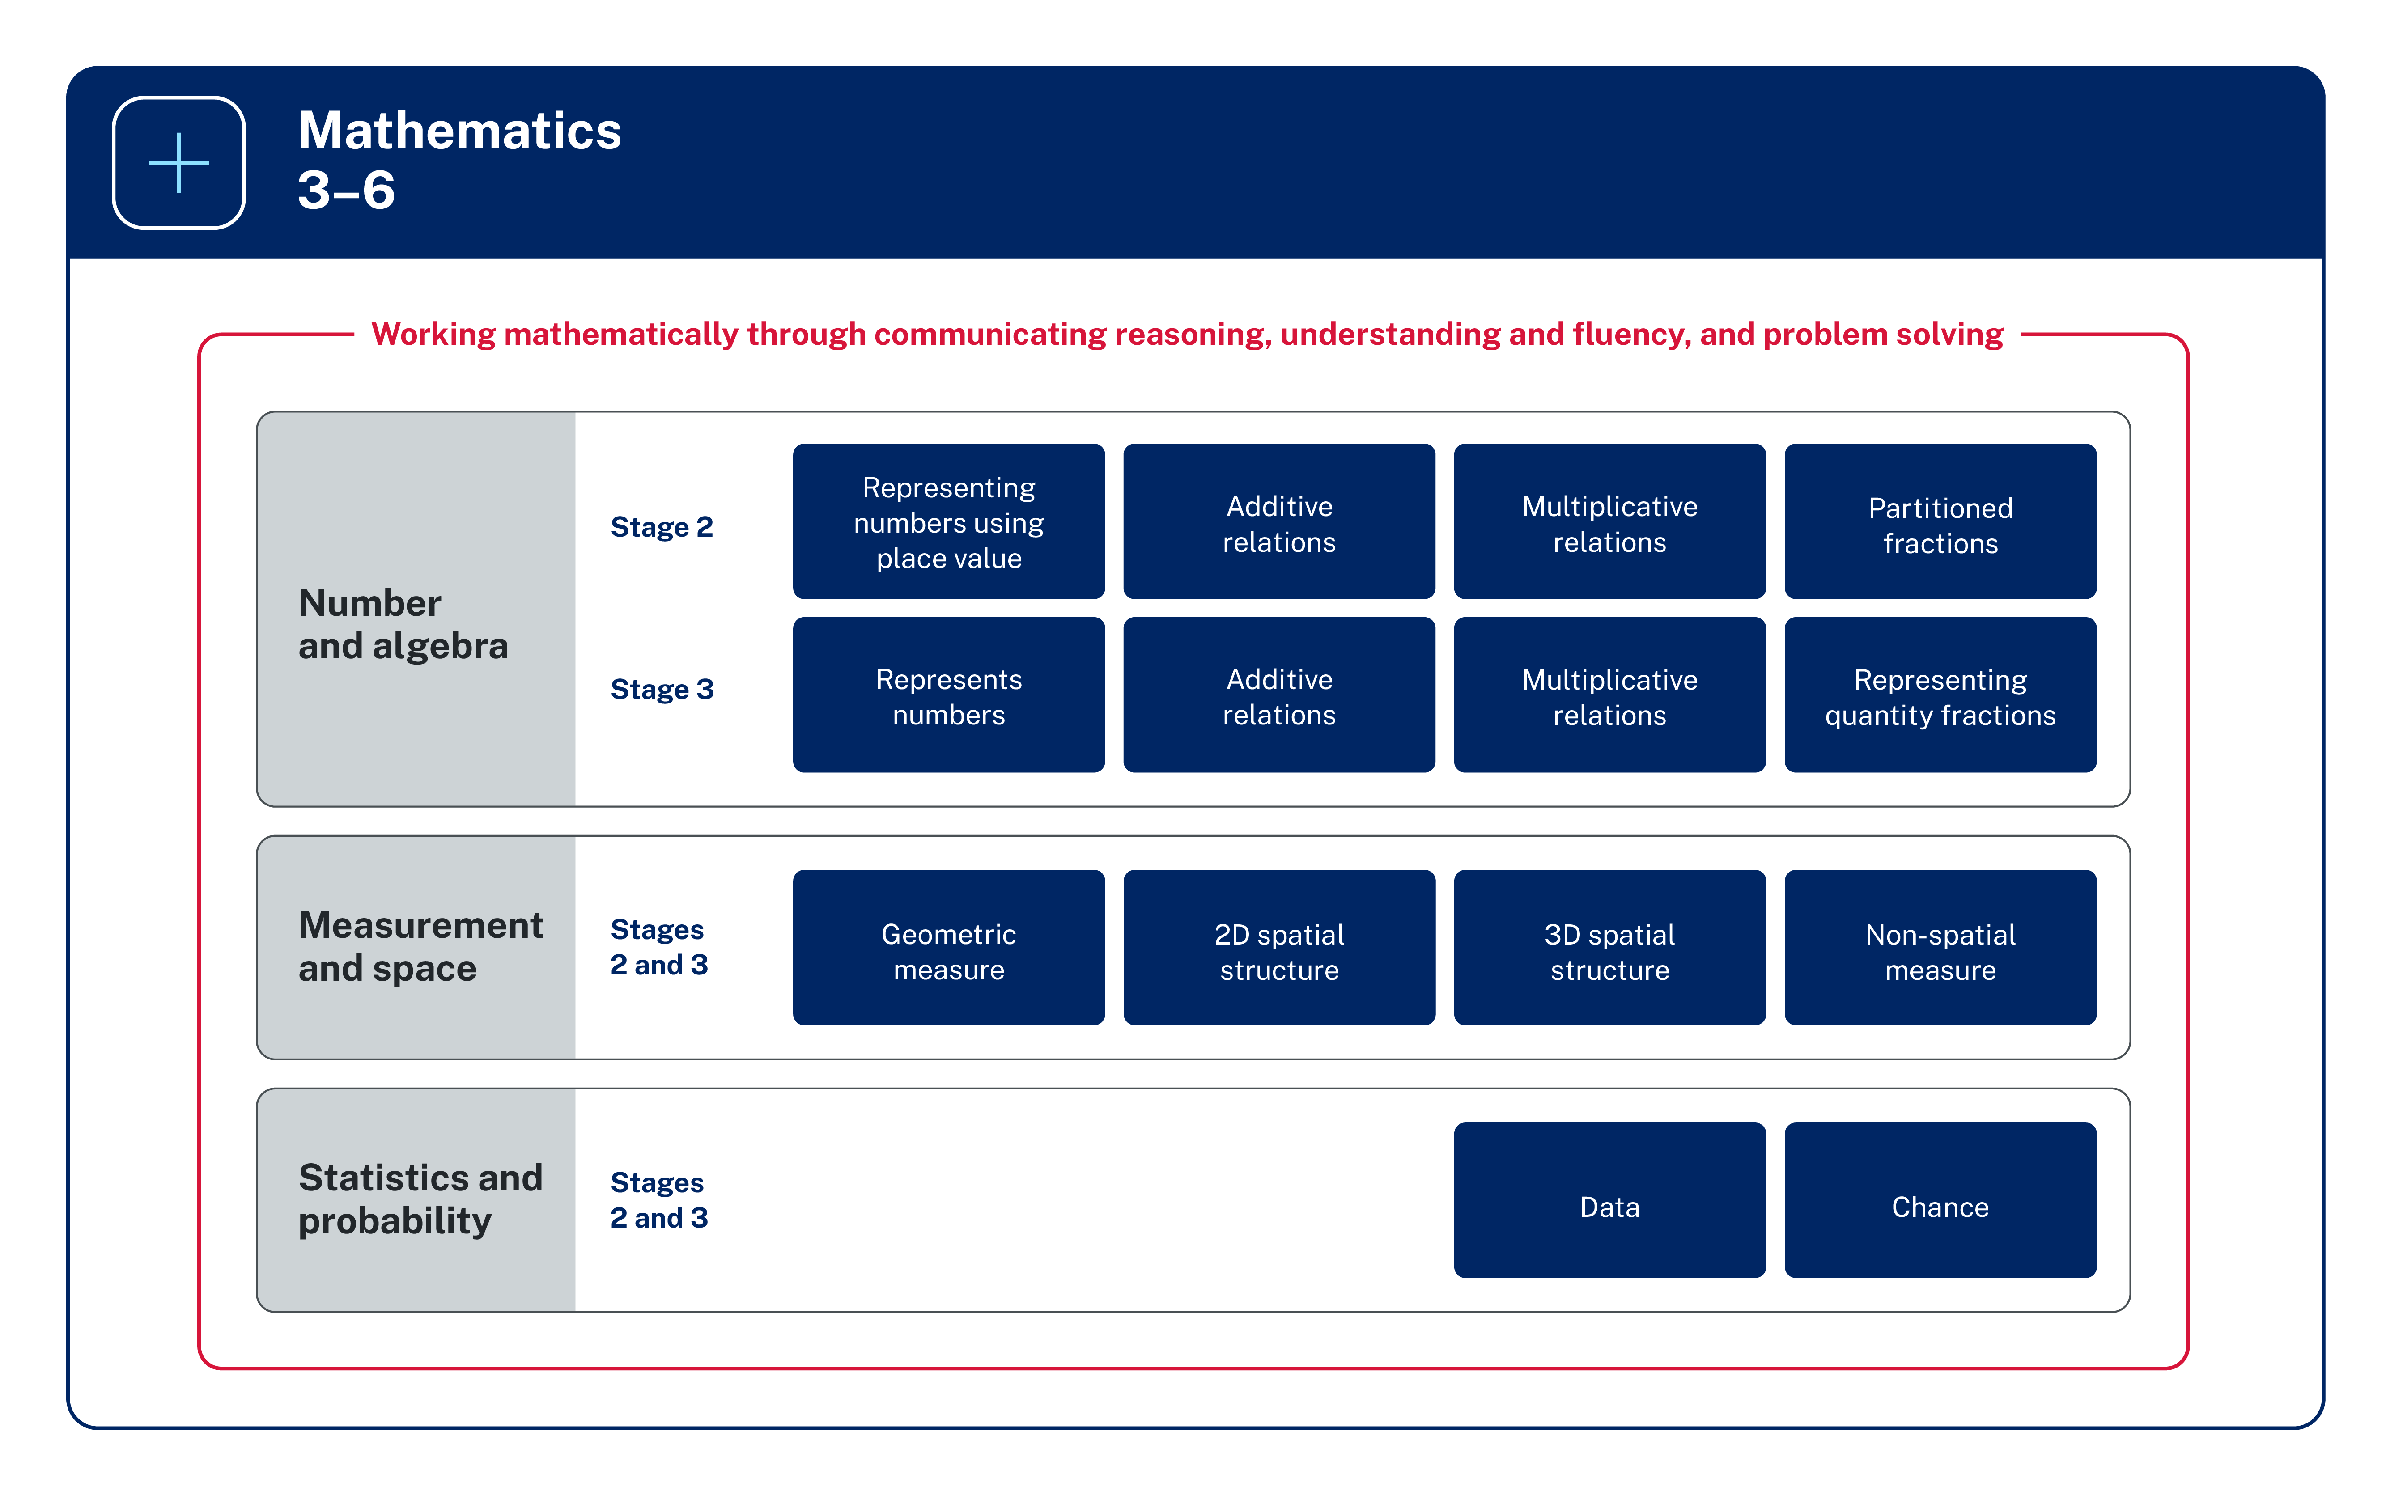
Figure 2: The organisation of Mathematics 3–6

Image long description: An overview of the syllabus structure for Stages 2 and 3 in Mathematics across the 3 areas of Number and algebra, Measurement and space, and Statistics and probability. Number and algebra reads horizontally across 2 stages – Stage 2 and Stage 3. Stage 2 learning areas include Representing numbers using place value, Additive relations, Multiplicative relations and Partitioned fractions. Stage 3 learning areas include Represents numbers, Additive relations, Multiplicative relations, and Representing quality fractions. Measurement and space reads horizontally across 2 stages – Stages 2 and 3. Learning areas include Geometric measure, 2D spatial structure, 3D spatial structure, and Non-spatial measure. Statistics and probability reads horizontally across 2 stages – Stages 2 and 3. Learning areas include Data and Chance.

K–6 Parts A and B
Mathematics focus areas outline the development of several concepts. In Mathematics K–6, where stages span 2 years of learning (for example, Stage 2 includes Year 3 and Year 4), there are concepts that may need to be addressed earlier or later in the stage.
To assist programming, the content in these focus areas has been separated into 2 parts, A and B, such as in Representing Numbers Using Place Value – A and Representing Numbers Using Place Value – B:
- Part A typically focuses on early concept development
- Part B builds on these early concepts.
The content across Parts A and B relates to the same stage-based outcomes. Teachers can choose which content from Part A and/or Part B to address, based on students’ prior learning, needs and abilities.
For example, in Stage 2, Part A does not equate to Year 3 only. When teaching a Year 4 class, the teacher may need to address or consolidate some concepts within Part A prior to addressing concepts in Part B. Similarly, when teaching a Year 3 class, the teacher may decide to address concepts in Part B based on the students’ prior learning, needs and abilities.
The Part A and Part B structure of the content:
- provides flexibility for teachers in planning teaching and learning programs based on the needs and abilities of students
- helps to better visualise the progression and growth of concepts within a stage of learning
- makes clear how content builds to support deep understanding in each focus area.
Considerations for planning teaching and learning programs include:
- when students may have learnt some concepts from Part B content in the first year of a stage, consolidation of these concepts in the second year of a stage may be needed
- revisiting concepts regularly to build deeper understanding of mathematical concepts
- providing extension of certain concepts based on students’ needs and abilities.

Making connections through related content K–6
Many connections exist between the focus areas in mathematics. Skills and knowledge for focus areas often develop in an interrelated manner and can be addressed in parallel.
Within the context of the syllabus, ‘in parallel’ means teaching:
- multiple focus areas at the same time
- parallel content in a sequential manner
- application of knowledge, understanding and skills through interrelated focus areas.
Addressing outcomes in parallel enables teachers to efficiently teach and assess essential concepts within the syllabus content while supporting students to make connections with their learning.
Examples of outcomes and content that could be addressed in parallel are identified for each focus area. These are not an exhaustive list of ways that knowledge, understanding and skills are related or can be taught in parallel.
- Making Connections Early Stage 1
- Making Connections Stage 1
- Making Connections Stage 2
- Making Connections Stage 3
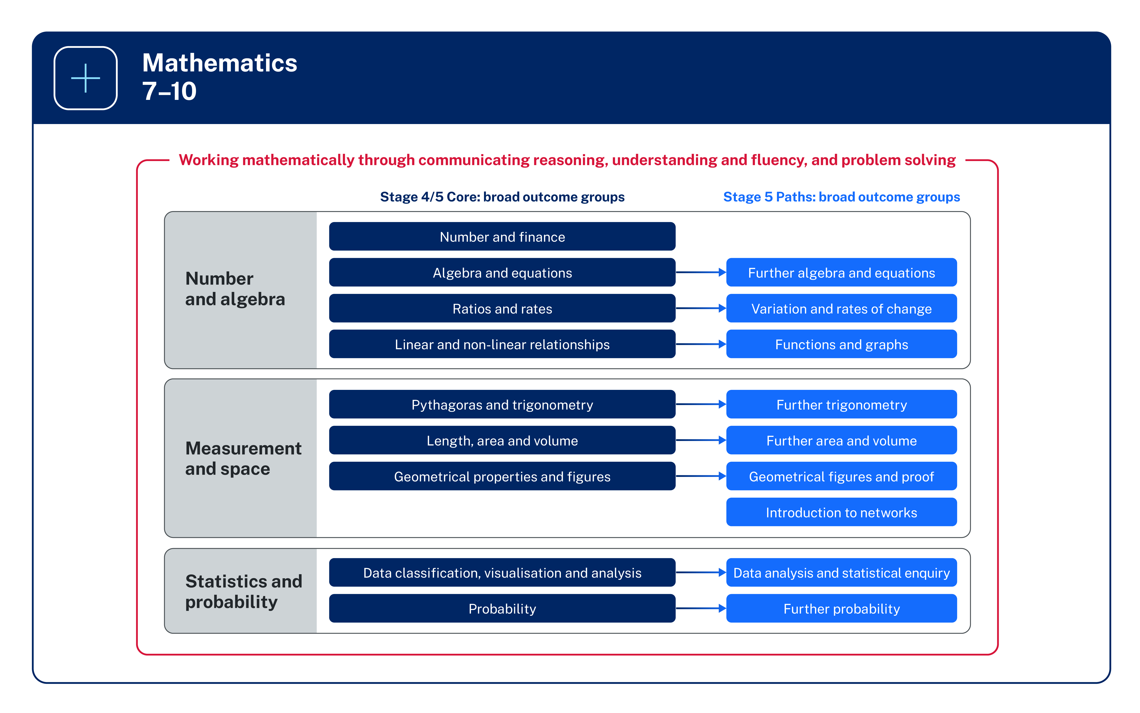
Figure 3: The organisation of Mathematics 7–10

Image long description: Stage 4/5 Core: broad outcome groups are Number and finance, Algebra and equations, Ratios and rates, Linear and non-linear relationships, Pythagoras and trigonometry, Length, area and volume, Geometrical properties and figures, Data classification, visualisation and analysis and Probability. Stage 5 Paths: broad outcome groups are Further algebra and equations, Variation and rates of change, Functions and graphs, Further trigonometry, Further area and volume, Geometrical figures and proof, Introduction to networks, Data analysis and statistical enquiry and Further probability. All content is surrounded by the phrase, Working mathematically through communicating reasoning, understanding and fluency, and problem solving.

7–10 Core–Paths structure
The Core–Paths structure is designed to encourage aspiration in students and provide the flexibility needed to enable teachers to create pathways for students working towards Stage 6. The structure is intended to extend students as far along the continuum of learning as possible and provide solid foundations for the highest levels of student achievement. The structure allows for a diverse range of endpoints up to the end of Stage 5.
The Core outcomes provide students with the foundation for Mathematics Standard 2 in Stage 6. Students who require ongoing support in completing all Stage 5 Core outcomes may consider either Mathematics Standard 1 or the Numeracy CEC course in Stage 6. For these students, teachers are encouraged to continue to extend students towards demonstrating achievement in as many Stage 5 Core outcomes as possible. This is to enable as many students as possible to have the knowledge and skills necessary to engage in the highest level of mathematics possible.
The aim for most students is to demonstrate achievement of the Core and as many Path outcomes as possible by the end of Stage 5 and this should guide teacher planning. Allowing time for students to demonstrate understanding of the Core outcomes must be a key consideration.
Typically, the Core will cover teaching and learning experiences up to the middle of Stage 5. It is not the intention of the Core–Paths structure to lock students into predetermined pathways at the end of Stage 4. Pathways in Stage 5 must be carefully planned to ensure some students have the opportunity to engage with Advanced and Extension courses.
Paths are used to progress students towards Stage 6 courses and may be implemented at any time in Stages 4 and 5 with careful consideration of the continuum of learning. Teachers also have the option of engaging with specific elements of Paths rather than the entire outcome to meet the needs of their students. Teachers should plan to cover as many Paths as practicable.

Course requirements K–10

Mandatory curriculum requirements 7–10
The mandatory curriculum requirements for eligibility for the award of the Record of School Achievement (RoSA) include that students:
- study the Board developed Mathematics syllabus substantially in each of Years 7–10 and
- complete at least 400 hours of Mathematics study by the end of Year 10.
Satisfactory completion of at least 200 hours of study in Mathematics during Stage 5 (Years 9 and 10) will be recorded with a grade. Students undertaking the Mathematics course based on Life Skills outcomes and content are not allocated a grade.
Course numbers:
- Mathematics: 326
- Mathematics Life Skills: 327
Exclusions: Students may not access both the Mathematics Years 7–10 outcomes and content and the Mathematics Life Skills outcomes and content.

Access content points K–6
Access content points have been developed to support students with significant intellectual disability who are working towards Early Stage 1 outcomes. These students may communicate using verbal and/or nonverbal forms.
For each of the Early Stage 1 outcomes, access content points are provided to indicate content that students with significant intellectual disability may access as they work towards the outcomes. Teachers will use the access content points on their own, or in combination with the content for each outcome.
Decisions regarding curriculum options for students with disability should be made in the context of collaborative curriculum planning.

Life Skills outcomes and content 7–10
Students with disability can access the syllabus outcomes and content in a range of ways. Decisions regarding curriculum options should be made in the context of collaborative curriculum planning.
Some students with intellectual disability may find the Years 7–10 Life Skills outcomes and content the most appropriate option to follow in Stage 4 and/or Stage 5. Before determining whether a student is eligible to undertake a course based on Life Skills outcomes and content, consideration should be given to other ways of assisting the student to engage with the Stage 4 and/or Stage 5 outcomes, or prior stage outcomes if appropriate. This assistance may include a range of adjustments to teaching, learning and assessment activities.
Life Skills outcomes cannot be taught in combination with other outcomes from the same subject. Teachers select specific Life Skills outcomes to teach based on the needs, strengths, goals, interests and prior learning of each student. Students are required to demonstrate achievement of one or more Life Skills outcomes.

Balance of content
The amount of content associated with a given outcome is not necessarily indicative of the amount of time spent engaging with the respective outcome. Teachers use formative and summative assessment to determine instructional priorities and the time needed for students to demonstrate expected outcomes.

Working at different stages
The content presented in a stage represents the typical knowledge, understanding and skills that students learn throughout the stage. It is acknowledged that students learn at different rates and in different ways. There may be students who will not demonstrate achievement in relation to one or more of the outcomes for the Stage.
There may be instances where teachers will need to address outcomes across different stages in order to meet the learning needs of students. Teachers are best placed to make decisions about when students need to work at, above or below stage level in relation to one or more of the outcomes. This recognises that outcomes may be achieved by students at different times across stages. Only students who are accelerated in a course may access Stage 6 outcomes.
For example:
- Students in Early Stage 1 could be working on Stage 1 content in the Number and Algebra strand, while working on Early Stage 1 content in the Measurement and Geometry strand.
- In Stage 2 or Stage 3, some students may not have developed a complete understanding of place value and the role of zero to read, write and order two-digit and three-digit numbers. These students will need to access content from Early Stage 1 or Stage 1 before engaging with Stage 2 content in applying place value to larger numbers and decimals.
- In Stage 4 some students may not have developed a complete understanding of fractions, decimals and percentages and will need to access related outcomes from Stage 3.

Rationale
Mathematical ideas have evolved and continue to develop across cultures and have been practised in Australia by Aboriginal and Torres Strait Islander Peoples for thousands of years. Through the study of mathematics, students apply their knowledge and skills to deepen their understanding of the world.
Mathematics is a reasoning and creative activity, integral to scientific and technological advances across many fields of endeavour. The symbolic nature of mathematics provides a powerful and precise means of communication.
Making connections across mathematical concepts and other subject areas enhances students’ ability to understand the purpose of learning mathematics and to develop a deeper conceptual understanding. This helps students to recognise the role of mathematics in solving problems in the world around them, applying their understanding to familiar and unfamiliar situations.
By studying mathematics, students develop essential numeracy skills and fluency, while nurturing the ability to think logically, critically and creatively. They learn about patterns and reason about relationships, creating opportunities to generalise their solutions and to solve non-routine problems.
When students enjoy learning mathematics, they develop a positive self-concept and become self-motivated learners through active participation in appropriately challenging tasks. This can enhance their resilience in solving mathematical problems relevant to further education and their everyday lives.

Aim
The aim of Mathematics K–10 is to enable students to become confident users of mathematics, learning and applying the language of mathematics to communicate efficiently and effectively. They develop an increasingly sophisticated understanding of mathematical concepts and a fluency with mathematical processes that helps them to interpret and solve problems. Students make connections within mathematics and connect mathematical concepts with the world around them. They learn to understand and appreciate how mathematics is a relevant part of their lives.

Table of outcomes

Secondary (7–10)
MAO-WM-01 Working mathematically
develops understanding and fluency in mathematics through exploring and connecting mathematical concepts, choosing and applying mathematical techniques to solve problems, and communicating their thinking and reasoning coherently and clearly
This outcome is aligned to all content in each Stage.
Focus area | Stage 4 | Stage 5
Computation with integers | MA4-INT-C-01  compares, orders and calculates with integers to solve problems | No Stage 5 outcomes
Fractions, decimals and percentages | MA4-FRC-C-01  represents and operates with fractions, decimals and percentages to solve problems | No Stage 5 outcomes
Ratios and rates | MA4-RAT-C-01  solves problems involving ratios and rates, and analyses distance–time graphs | MA5-RAT-P-01  identifies and solves problems involving direct and inverse variation and their graphical representations (Path: Stn, Adv)  MA5-RAT-P-02  analyses and constructs graphs relating to rates of change (Path: Stn, Adv)
Algebraic techniques | MA4-ALG-C-01  generalises number properties to operate with algebraic expressions including expansion and factorisation | MA5-ALG-C-01  simplifies algebraic fractions with numerical denominators and expands algebraic expressions  MA5-ALG-P-01  simplifies algebraic fractions involving indices, and expands and factorises algebraic expressions (Path: Adv)  MA5-ALG-P-02  selects and applies appropriate algebraic techniques to operate with algebraic fractions, and expands, factorises and simplifies algebraic expressions (Path: Adv)
Indices | MA4-IND-C-01  operates with primes and roots, positive-integer and zero indices involving numerical bases and establishes the relevant index laws | MA5-IND-C-01  simplifies algebraic expressions involving positive-integer and zero indices, and establishes the meaning of negative indices for numerical bases  MA5-IND-P-01  applies the index laws to operate with algebraic expressions involving negative-integer indices (Path: Adv)  MA5-IND-P-02  describes and performs operations with surds and fractional indices (Path: Adv)
Equations | MA4-EQU-C-01  solves linear equations of up to 2 steps and quadratic equations of the form $${ax}^{2}=c$$ | MA5-EQU-C-01  solves linear equations of up to 3 steps, limited to one algebraic fraction  MA5-EQU-P-01  solves monic quadratic equations, linear inequalities and cubic equations of the form $${ax}^{3}=k$$ (Path: Adv)  MA5-EQU-P-02  solves linear equations of more than 3 steps, monic and non-monic quadratic equations, and linear simultaneous equations (Path: Adv)
Linear relationships | MA4-LIN-C-01  creates and displays number patterns and finds graphical solutions to problems involving linear relationships | MA5-LIN-C-01  determines the midpoint, gradient and length of an interval, and graphs linear relationships, with and without digital tools  MA5-LIN-C-02  graphs and interprets linear relationships using the gradient/slope-intercept form  MA5-LIN-P-01  describes and applies transformations, the midpoint, gradient/slope and distance formulas, and equations of lines to solve problems (Path: Adv)
Length | MA4-LEN-C-01  applies knowledge of the perimeter of plane shapes and the circumference of circles to solve problems | No Stage 5 outcomes
Pythagoras and trigonometry  Includes:  Stage 4: Right-angled triangles (Pythagoras’ theorem) | MA4-PYT-C-01  applies Pythagoras’ theorem to solve problems in various contexts | MA5-TRG-C-01  applies trigonometric ratios to solve right-angled triangle problems  MA5-TRG-C-02  applies trigonometry to solve problems, including bearings and angles of elevation and depression  MA5-TRG-P-01  applies Pythagoras’ theorem and trigonometry to solve 3-dimensional problems and applies the sine, cosine and area rules to solve 2-dimensional problems, including bearings (Path: Stn, Adv)  MA5-TRG-P-02  establishes and applies the properties of trigonometric functions and finds solutions to trigonometric equations (Path: Adv)
Area and surface area  Includes:  Stage 4: Area | MA4-ARE-C-01  applies knowledge of area and composite area involving triangles, quadrilaterals and circles to solve problems | MA5-ARE-C-01  solves problems involving the surface area of right prisms and practical problems involving the area of composite shapes and solids  MA5-ARE-P-01  applies knowledge of the surface area of right pyramids and cones, spheres and composite solids to solve problems (Path: Stn, Adv)
Volume | MA4-VOL-C-01  applies knowledge of volume and capacity to solve problems involving right prisms and cylinders | MA5-VOL-C-01  solves problems involving the volume of composite solids consisting of right prisms and cylinders  MA5-VOL-P-01  applies knowledge of the volume of right pyramids, cones and spheres to solve problems involving related composite solids (Path: Stn, Adv)
Angle relationships | MA4-ANG-C-01  applies angle relationships to solve problems, including those related to transversals on sets of parallel lines | No Stage 5 outcomes
Properties of geometrical figures | MA4-GEO-C-01  identifies and applies the properties of triangles and quadrilaterals to solve problems | MA5-GEO-C-01  identifies and applies the properties of similar figures and scale drawings to solve problems  MA5-GEO-P-01  establishes conditions for congruent triangles and similar triangles and solves problems relating to properties of similar figures and plane shapes (Path: Ext)  MA5-GEO-P-02  constructs proofs involving congruent triangles and similar triangles and proves properties of plane shapes (Path: Ext)
Data classification and visualisation | MA4-DAT-C-01  classifies and displays data using a variety of graphical representations | No Stage 5 outcomes
Data analysis | MA4-DAT-C-02  analyses simple datasets using measures of centre, range and shape of the data | MA5-DAT-C-01  compares and analyses datasets using summary statistics and graphical representations  MA5-DAT-C-02  displays and interprets datasets involving bivariate data  MA5-DAT-P-01  plans, conducts and reviews a statistical inquiry into a question of interest (Path: Stn, Adv)
Probability | MA4-PRO-C-01  solves problems involving the probabilities of simple chance experiments | MA5-PRO-C-01  solves problems involving probabilities in multistage chance experiments and simulations  MA5-PRO-P-01  solves problems involving Venn diagrams, 2-way tables and conditional probability (Path: Adv)
Numbers of any magnitude | No Stage 4 outcomes | MA5-MAG-C-01  solves measurement problems by using scientific notation to represent numbers and rounding to a given number of significant figures
Polynomials (Path) | No Stage 4 outcomes | MA5-POL-P-01  defines, operates with and graphs polynomials and applies the factor and remainder theorems to solve problems (Path: Adv, Ext)
Logarithms (Path) | No Stage 4 outcomes | MA5-LOG-P-01  establishes and applies the laws of logarithms to solve problems (Path: Adv)
Functions and other graphs (Path) | No Stage 4 outcomes | MA5-FNC-P-01  uses function notation to describe and graph functions of one variable and graphs inequalities in one and 2 variables (Path: Adv)
Circle geometry (Path) | No Stage 4 outcomes | MA5-CIR-P-01  applies deductive reasoning to prove circle theorems and solve related problems (Path: Ext)
Introduction to networks (Path) | No Stage 4 outcomes | MA5-NET-P-01  solves problems involving the characteristics of graphs/networks, planar graphs and Eulerian trails and circuits (Path: Stn)
Before deciding that a student should undertake a course based on Life Skills outcomes and content, consideration should be given to other ways of assisting the student to engage with the Stage 4 or Stage 5 outcomes. Further information in relation to planning, implementing and assessing Life Skills outcomes and content can be found on the NESA website.

Outcomes and content for Stage 4

Computation with integers

Outcomes
A student:
- develops understanding and fluency in mathematics through exploring and connecting mathematical concepts, choosing and applying mathematical techniques to solve problems, and communicating their thinking and reasoning coherently and clearly MAO-WM-01
- compares, orders and calculates with integers to solve problems MA4-INT-C-01
Related Life Skills outcomes: MALS-LAN-01, MALS-LAN-02, MALS-COU-01, MALS-REP-01, MALS-COM-01, MALS-ADS-01, MALS-MDI-01

Content

Compare and order integers
- Recognise and describe the direction and magnitude of integers
Example(s):
Recognising that the temperature on a warm, sunny day is 23 °C while the temperature in the snow is −10 °C.
NPV9
- Identify and represent integers on a number line
Example(s):
Using digital tools to identify and record temperatures above and below zero from local Aboriginal Nations and various cities around the world, at a particular point in time.
Using real-life situations to represent positive and negative integers, such as a building with underground parking, sea level or a thermometer.
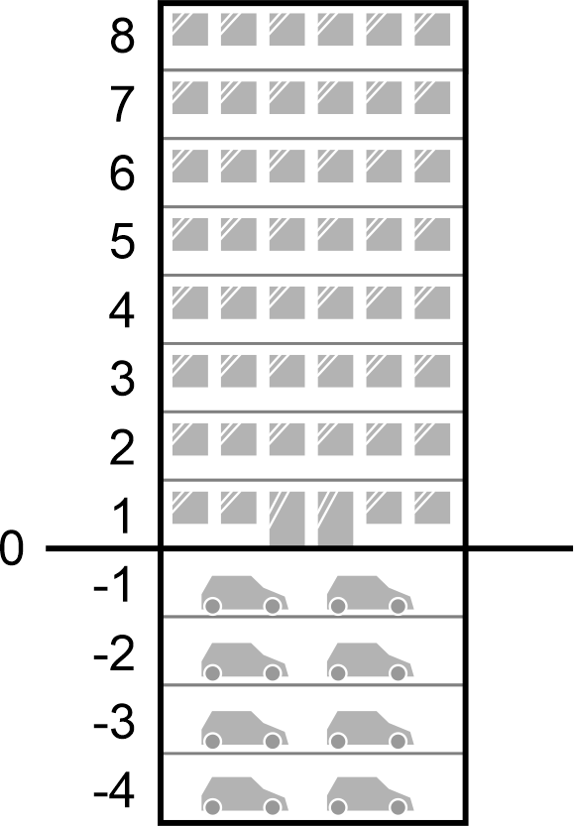
NPV9
- Compare the relative value of integers using the less than (<) and greater than (>) symbols
Example(s):
Demonstrating that $$5>-4$$ and $$-5<-1$$.
NPV9
- Order integers
Example(s):
Arranging a set of numbers in descending order and justifying the order using a number line.
NPV9

Add and subtract positive and negative integers
- Add and subtract integers with and without the use of digital tools
Example(s):
Using a number line to show that $$3+\left(-5\right)=-2$$.
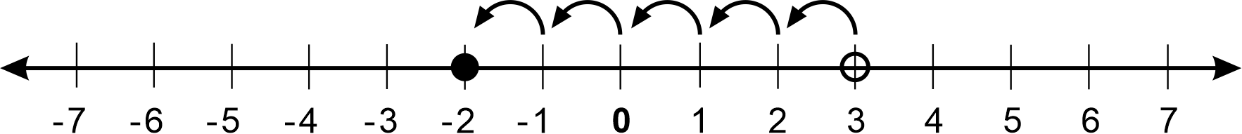
Recognising time zones and calculating the time difference between 2 locations using a number line.
AdS10
- Construct a directed number sentence to model a situation
Example(s):
Constructing a directed number sentence for the situation where a student has $10 in their bank account and $12 worth of fees are charged resulting in a balance of negative $2.

- Examine different meanings (position or operation) for the $$+$$ and $$-$$signs, depending on context

Multiply and divide positive and negative integers
- Represent multiples of negative integers as repeated addition
Example(s):
Considering$$4×-3$$ as $$\left(-3\right)+\left(-3\right)+\left(-3\right)+\left(-3\right)$$ and $$-4×-3$$ as $$-\left.[\left(-3\right)+\left(-3\right)+\left(-3\right)+\left(-3\right)]\right.$$.
Representing $$4×-2$$ as repeated addition on a number line:
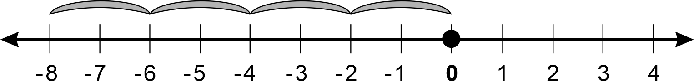
Image long description: Number line demonstrates that 4 multiplied by minus 2 is the same as minus 2, plus minus 2, plus minus 2, plus minus 2.
MuS9
- Multiply and divide positive and negative integers with and without the use of digital tools
Example(s):
Considering the outcome of squaring a negative number, and explaining the difference in value of $${\left(-4\right)}^{2}$$ and $$-4^{2}$$.
MuS9

Apply the 4 operations to integers
- Apply the 4 operations to integers
AdS10, MuS9
- Solve problems involving grouping symbols with integers
- Apply the order of operations to evaluate expressions involving integers, with and without the use of digital tools
Example(s):
Evaluating $$\frac{15 + 9}{6}$$, $$\frac{15 + 9}{15 - 3}$$, $$5+\frac{18 - 12}{6}-12$$ and $$5×\left(2-8\right)$$.

Fractions, decimals and percentages

Outcomes
A student:
- develops understanding and fluency in mathematics through exploring and connecting mathematical concepts, choosing and applying mathematical techniques to solve problems, and communicating their thinking and reasoning coherently and clearly MAO-WM-01
- represents and operates with fractions, decimals and percentages to solve problems MA4-FRC-C-01
Related Life Skills outcomes: MALS-FRC-01, MALS-DEP-01

Content

Compare fractions using equivalence
- Determine the highest common factor (HCF) of 2 whole numbers
Example(s):
Describing the HCF of 16 and 24 as 8.
MuS9
- Examine methods of generating equivalent fractions
Example(s):
Representing$$\frac{2}{3}$$using an area model and a number line to demonstrate how each diagram can be modified to show the equivalence to$$\frac{4}{6}$$ (halving each unit doubles the number of units).
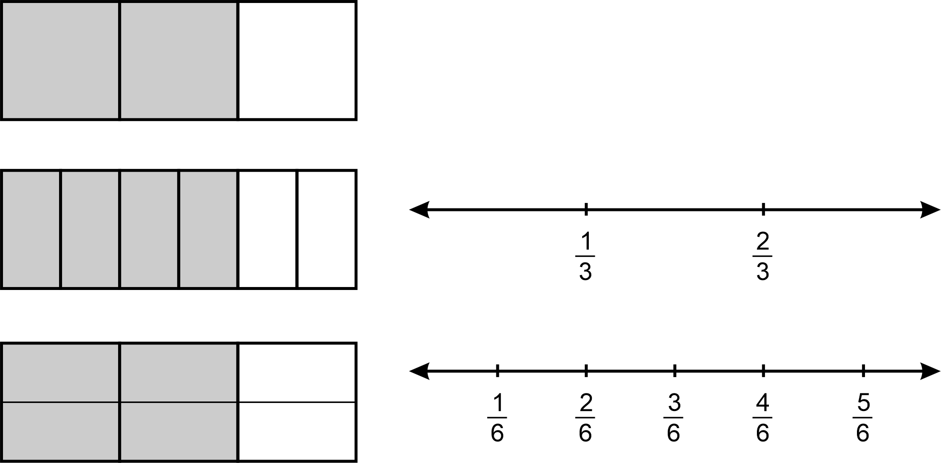
Image long description: 2 rectangles, one with 2 thirds shaded in and the other with 4 sixths shaded in. Rectangle with 2 thirds shaded. A dotted line divides it into sixths. 2 number lines showing that a third is equal to 2 sixths, and that 2 thirds is equal to 4 sixths.

- Simplify fractions by using methods, including determining the HCF of the numerator and denominator or repeated simplification using common factors
Example(s):
Simplifying $$\frac{12}{16}$$to$$\frac{3}{4}$$.
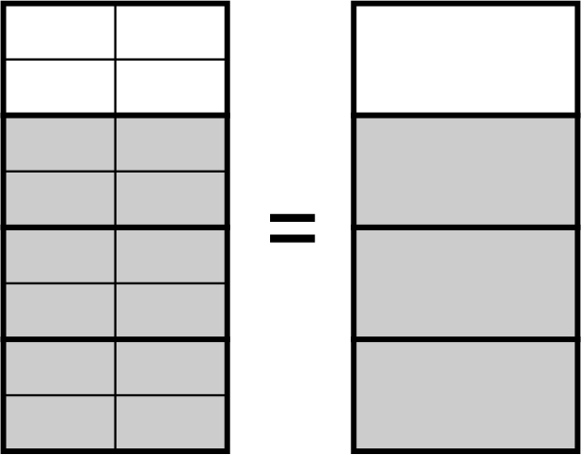

- Create fractions with the same denominator to compare their sizes
- Compare and order fractions with different denominators
Example(s):
Comparing the fractions $$\frac{1}{2}$$, $$\frac{2}{3}$$ and $$\frac{3}{8}$$ using digital or concrete manipulatives and putting them in ascending order.

Round decimals to a specified degree of accuracy using approximations
- Round decimals to a given number of decimal places
NPV9
- Apply the notation ≈ as a symbol of numerical approximation
- Reason why an approximation may be more appropriate than an exact answer and vice versa
Example(s):
Explaining that when finding the volume of a cylinder, the exact answer in terms $$π$$ is not appropriate to estimate the number of 250 mL cups required to fill that cylinder.

Identify terminating and recurring decimals
- Use either dot or vinculum notation for recurring (repeating) decimals
Example(s):
Representing the following using recurring decimal notation: $$\frac{1}{3}=0.33333…=0.\overset{˙}{3}, 0.345345345…=0.\overset{-}{345}, 0.266666…=0.2\overset{˙}{6}$$

- Classify decimals as recurring or terminating
Example(s):
Examine the results of dividing 1 by other single-digit numbers and classify the results as recurring or terminating decimals.

Identify and make use of the relationship between fractions, decimals and percentages to carry out simple conversions
- Define rational numbers as numbers that can be written in the form $$\frac{a}{b}$$, where $$a$$ and $$b$$ are integers and$$b≠0$$
Example(s):
Recognising that 2 is a rational number as it can be written as $$\frac{2}{1}$$ and 47% is a rational number as it can be converted to $$\frac{47}{100}$$.

- Classify fractions and percentages as rational numbers
- Recognise and explain that numbers with terminating or recurring decimals are rational
Example(s):
Explaining why decimals such as $$0.9$$and$$0.53535353 …$$ are rational numbers by first expressing them as fractions $$\frac{9}{10}$$ or $$\frac{53}{99}$$.

- Represent fractions as decimals (terminating and recurring) and percentages
Example(s):
Recognising that$$\frac{2}{3}$$can be displayed as $$0.6666666667$$ on a calculator.
Using some of the digits from$$0$$to $$9$$, at most once each, create a true statement of the form:
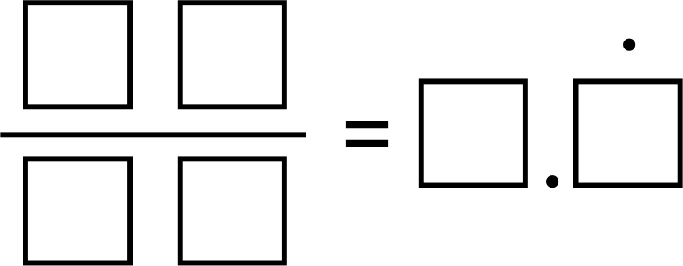

- Represent terminating decimals as fractions and percentages
- Represent improper fractions as mixed numbers and decimals, and vice versa
- Represent percentages as fractions and decimals
PrT2

Examine the concept of irrational numbers
- Identify and define irrational numbers as numbers that cannot be written in the form $$\frac{a}{b}$$ where $$a$$ and $$b$$ are integers and $$b≠0$$
Example(s):
Identifying $$\sqrt{2}$$ and $$π$$ as irrational numbers and explaining that $$\frac{22}{7}$$ is an approximation for $$π$$.

- Find approximations of irrational numbers using digital tools
- Locate the approximate position of irrational numbers on a number line
Example(s):
Showing the approximate position of $$π$$on a number line by choosing an appropriate scale using fractions or decimals.
Demonstrating a method of locating $$\sqrt{2}$$ on a number line using compasses or digital tools:
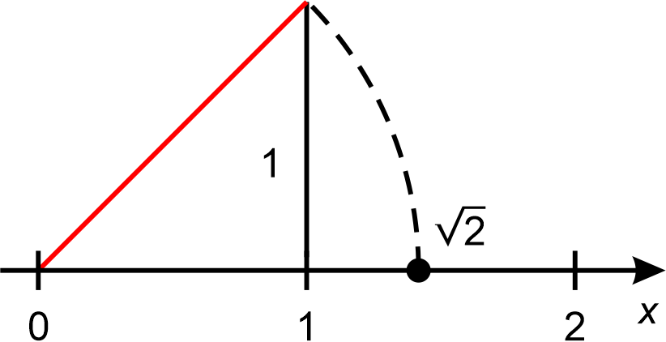
Image long description: Number line between zero and 2. At number one, a vertical line is drawn. A straight, angled line is drawn from zero to the top of the vertical line. A dotted line is drawn from the vertical line to hit the number line at a point between 1 and 2. This point is labelled as the square root of 2.

Order and compare the value of fractions, decimals and percentages
- Locate positive and negative fractions, decimals and mixed numbers on a number line to compare their relative values
Example(s):
Choosing the appropriate scale on a number line to represent $$-\frac{5}{6}$$,$$\frac{7}{8}$$and$$1\frac{1}{4}$$.
NPV9
- Compare and order fractions, mixed numbers, decimals (terminating and recurring) and percentages
Example(s):
Arranging the following in ascending order: $$\frac{1}{2}$$, $$0.3\overset{˙}{5}$$, 75%, $$\frac{3}{5}$$, 17%, 0.02, $$1\frac{4}{5}$$ and 0.8 by first converting all terms to either a fraction, decimal or percentage.

Solve problems that involve the addition and subtraction of fractions
- Represent addition and subtraction of fractions with the same or unrelated denominators
AdS9, AdS10, InF8
- Solve problems involving adding and subtracting fractions and mixed numbers, including finding a common denominator
Example(s):
Recognising and explaining why$$\frac{2}{3}+\frac{1}{4}≠\frac{3}{7}$$.
AdS10
- Solve problems that involve subtracting a fraction from a whole number, with and without the use of digital tools

Solve problems that involve the multiplication and division of fractions and decimals
- Compare and generalise the effect of multiplying or dividing by a number with magnitude between zero and one
Example(s):
Explaining why the number 10 gets smaller when multiplied by $$\frac{1}{4}$$.
MuS9, InF8
- Represent multiplication and division of decimals
Example(s):
Representing $$0.6÷0.2=3$$.
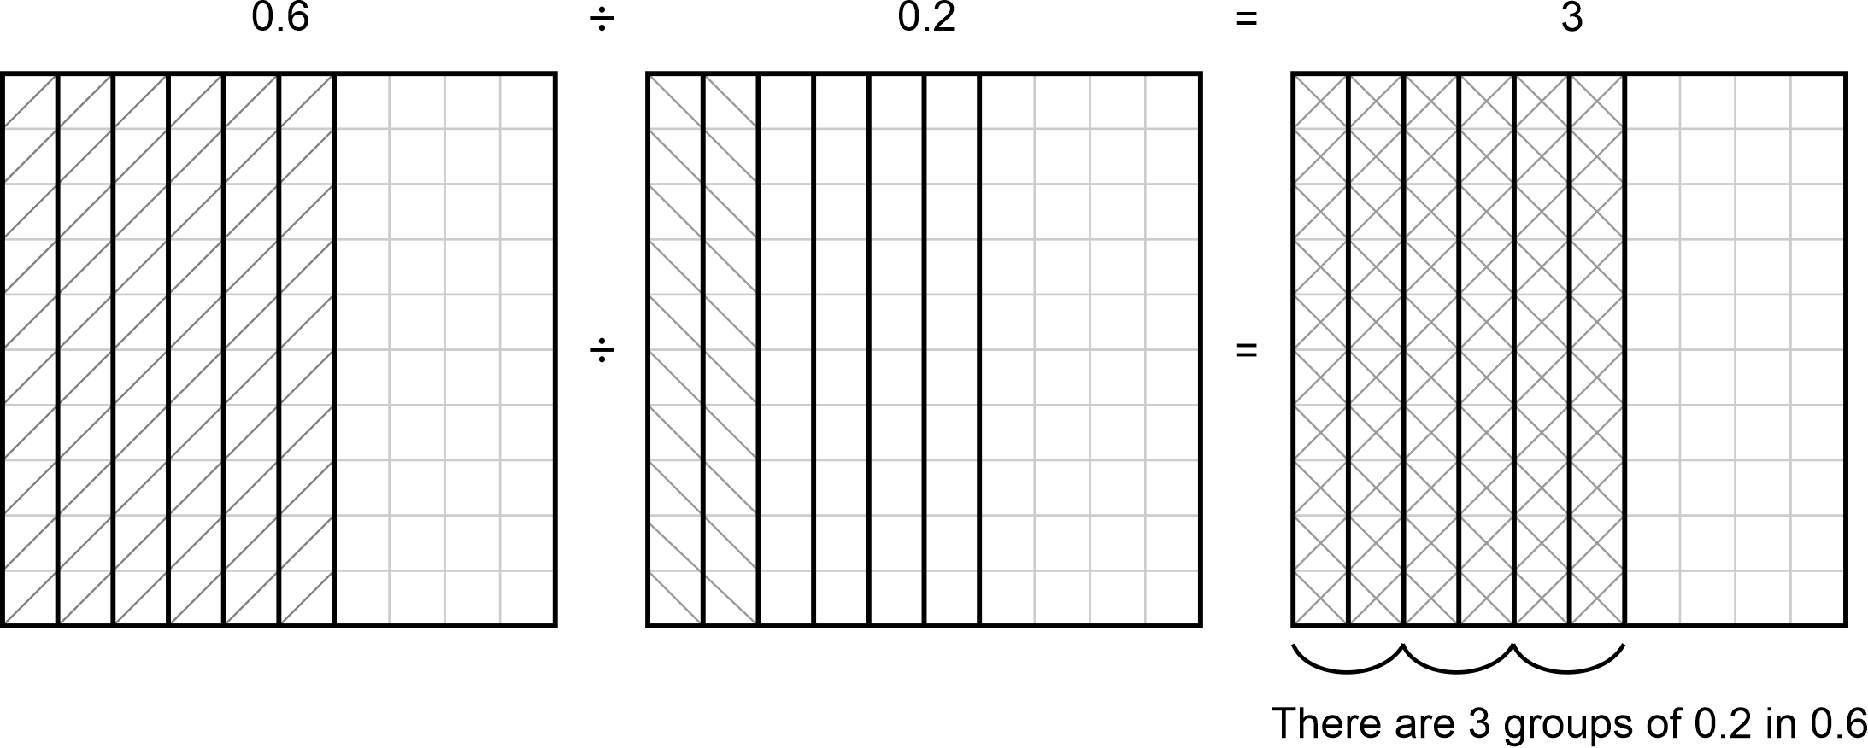
Image long description: A 10 by 10 square grid with 6 columns shaded divided by a 10 by 10 square grid with 2 columns of the 6 columns shaded equalling a 10 by 10 square grid with 6 columns shaded showing 3 groups of 0.2 in 0.6

- Represent multiplication and division of fractions, including mixed numbers
Example(s):
Representing $$\frac{1}{3}×\frac{4}{5}=\frac{4}{15}$$.
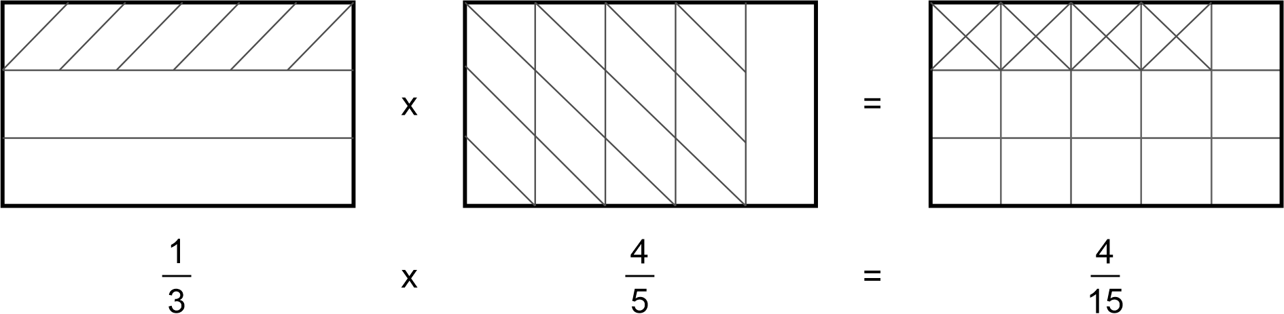
Image long description: A rectangle divided into 3 equal rows with 1 row shaded multiplied by a rectangle divided into 5 equal columns with 4 columns shaded equalling a rectangle divided into 15 equal squares with 4 squares shaded.

- Multiply and divide decimals, using digital tools to solve problems
- Multiply and divide fractions and mixed numbers, with and without using digital tools to solve problems
Example(s):
Evaluating $$3\frac{2}{5}×2\frac{4}{7}$$ and $$\frac{2}{9}÷1\frac{1}{7}$$.
MuS10
- Compare initial estimates with the results of calculations
- Apply knowledge of fractions and decimals of quantities to solve problems
Example(s):
Verifying whether $$\frac{3}{7}$$ of $4.50 is a little bit less than half of $4.50.
MuS9
- Apply knowledge of multiplication and division of fractions and decimals to solve problems
Example(s):
Creating a true statement with the form below using some of the digits from 1 to 9, without using a digit more than once:
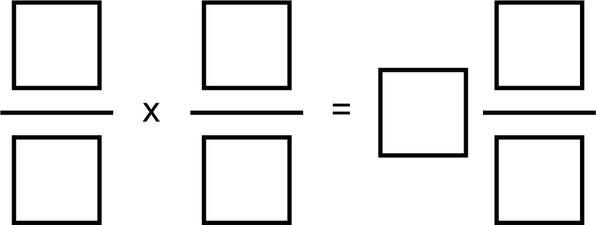
MuS9, MuS10

Represent one quantity as a fraction, decimal or percentage of another, with and without the use of digital tools
- Represent one quantity as a fraction, decimal or percentage of another by considering appropriate units
Example(s):
Examining equivalence in fractions, decimals and percentage forms in the patterns used in textiles, music, designs and/or artworks of Aboriginal and/or Torres Strait Islander Peoples.
InF8
- Calculate percentage increases and decreases in various contexts
Example(s):
Evaluating the final price of a laptop that was selling for $2780 and was reduced by 28% during an online shopping event.
PrT6
- Examine the financial applications of percentage increase and decrease, including profit and/or loss as a percentage of cost price or selling price
PrT6, UnM9

Solve problems that involve the use of percentages
- Apply knowledge of percentages to calculate quantities in various contexts
Example(s):
Explaining why multiplying by 1.05 will increase a number/quantity by 5% and multiplying by 0.87 will decrease a number/quantity by 13%.
PrT6, PrT2
- Apply knowledge of percentage increases and decreases to solve problems in various contexts
Example(s):
Exploring the situation of increasing an amount by a percentage and decreasing the result by an identical percentage and reasoning why the result is not the original amount.
PrT6
- Solve real-life problems involving percentages using the unitary method or other techniques
Example(s):
Examining the percentage of land taken up by particular Aboriginal Nations, such as Bundjalung, Wonnarua, Dunghutti, compared to the total land area of New South Wales.
PrT5
- Solve financial problems involving percentages, specifically considering GST, profit and loss
Example(s):
Evaluating the final cost after 10% GST is added to an electrical job that costs $720.
PrT6, UnM8, UnM9

Ratios and rates

Outcomes
A student:
- develops understanding and fluency in mathematics through exploring and connecting mathematical concepts, choosing and applying mathematical techniques to solve problems, and communicating their thinking and reasoning coherently and clearly MAO-WM-01
- solves problems involving ratios and rates, and analyses distance–time graphs MA4-RAT-C-01
Related Life Skills outcomes: MALS-ADS-01, MALS-MDI-01

Content

Recognise and simplify ratios
- Use ratios to compare 2 or more quantities measured in the same units
PrT3
- Identify and express one part of a ratio as a fraction of the whole
Example(s):
Using a diagram to model the ratio 4:7, showing that the first part is $$\frac{4}{11}$$ of the whole:

PrT3, InF9
- Simplify ratios
PrT5

Solve problems involving ratios
- Apply the unitary method to solve ratio problems
Example(s):
Finding the number of students in Year 7 if there are 105 students in Year 8 and the ratio of Year 7 students to Year 8 students is 4:3:
3 parts $$=$$ 105
1 part = $$\frac{105}{3}$$
$$∴$$ 4 $$×$$ 35 $$=$$ 140 Year 7 students

- Divide a quantity in a given ratio
Example(s):
Dividing $50 in the ratio 1:3.
PrT5
- Solve real-life problems involving ratios
Example(s):
Calculating the ingredients needed if a recipe is adjusted for more or less people than the original recommendation.
Calculating the actual distance between Dunghutti Country, South West Rocks and Gumbaynggirr Country, Coffs Harbour, in kilometres if the scale on a map is given as 1:1 000 000 and the distance between the 2 towns on the map is 10 cm.
PrT5, PoL5

Recognise and simplify rates
- Explain the differences between ratios and rates
Example(s):
Describing ratios as a comparison of quantities measured in the same units and rates as a comparison of quantities measured in different units.
PrT3
- Represent given information as a simplified rate
PrT5
- Convert between units for rates
Example(s):
Converting between km/h and m/s and vice versa.
PrT5

Solve problems involving rates
- Solve a variety of real-life problems involving rates
PrT5
- Examine financial applications of rates, such as best buys
PrT5, UnM9

Interpret and construct distance–time graphs from authentic data
- Interpret distance–time graphs made up of straight-line segments with a negative, zero or positive slope
Example(s):
Explaining the significance of horizontal line segments in distance–time graphs.
Interpreting a graph which shows the distance covered and time taken during a car journey of a person and their sibling who leave home to visit their relative’s house. After visiting their relative, the person drops off their sibling at a friend’s house before going home. Using the below diagram, answer: What is the speed of the car from the person’s home to their relative’s house? How long did they stay at their relative’s house? How far is the friend’s house from their home? What is the speed of the car coming home?
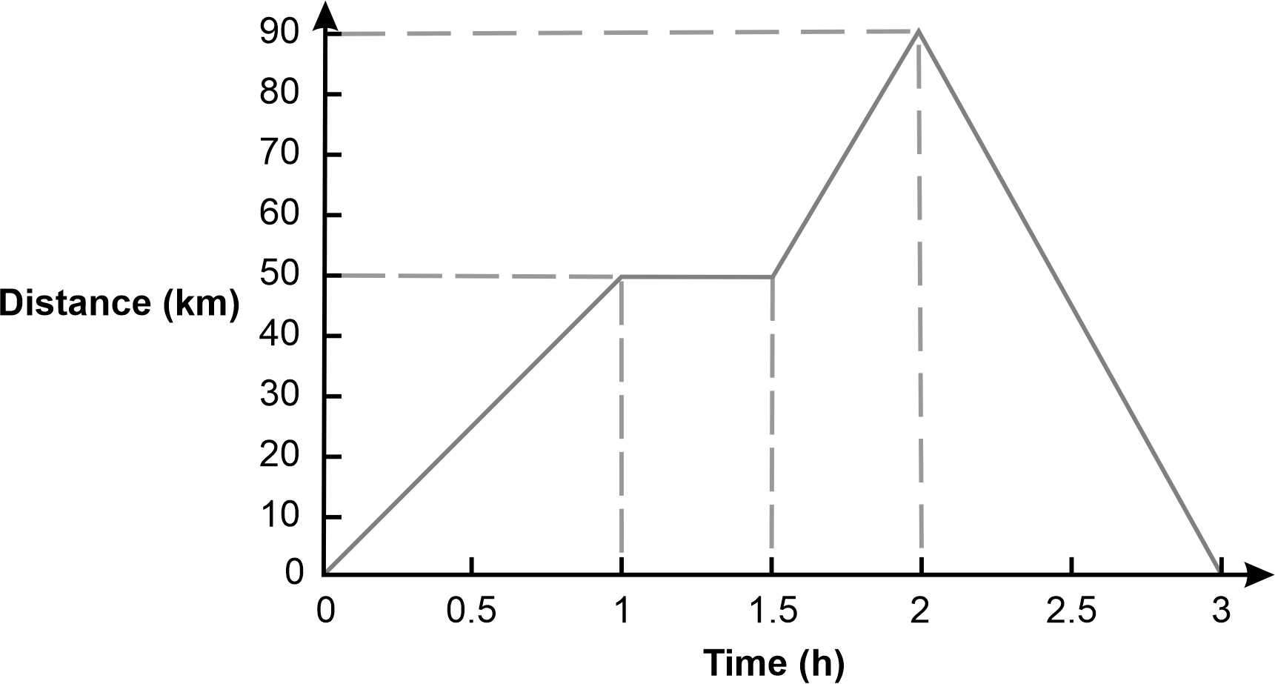
Image long description: A graph with distance in kilometres on the vertical axis and time in hours on the horizontal axis. First line slopes upward and travels 50 km in 1 hour. Second line is horizontal for 30 minutes. Third line slopes upward and travels a further 40 km in 30 minutes. Fourth line slopes downward and travels 90 km over 1 hour.
IRD6, MeT7
- Calculate speeds for straight-line segments of given distance–time graphs
IRD6, MeT7
- Create distance–time graphs made up of straight-line segments

Algebraic techniques

Outcomes
A student:
- develops understanding and fluency in mathematics through exploring and connecting mathematical concepts, choosing and applying mathematical techniques to solve problems, and communicating their thinking and reasoning coherently and clearly MAO-WM-01
- generalises number properties to operate with algebraic expressions including expansion and factorisation MA4-ALG-C-01
Related Life Skills outcomes: MALS-PAT-01

Content

Examine the concept of pronumerals as a way of representing numbers
- Examine and recognise that pronumerals can be used to represent one or more numerical values and when pronumerals have more than one numerical value, they may then be referred to as variables
Example(s):
Explaining that $$x+3$$ takes on different values for $$x=1, x=5, x=10$$.
Exploring the use of symbols in storytelling by Aboriginal and/or Torres Strait Islander Peoples, including mathematical stories.
NPA6
- Identify and define an algebraic expression as an expression formed by combining numbers and algebraic symbols using arithmetic operations
Example(s):
Describing $$4x-2$$ and $$5\left(2x+x^{2}\right)$$ as algebraic expressions.
NPA6
- Use concise algebraic notation and conventions for multiplication, division and powers, and explain the meanings for each convention
Example(s):
Representing $$a÷\left(b×c\right)$$ as $$\frac{a}{bc}$$ , $$a÷b×c$$ as $$\frac{a}{b}×c$$ and $$\frac{ac}{b}$$ , half of $$x$$ as $$\frac{1}{2}x$$or $$\frac{x}{2}$$, $$1×x$$ as $$x$$.
$$4×4=16=4^{2}$$, $$3×3×3=27=3^{3}∴a×a=a^{2}$$, $$b×b×b=b^{3}$$ and $$c×c×c×c=c^{4}$$.
NPA6

Create algebraic expressions and evaluate them by substitution
- Generate algebraic expressions by translating descriptions and vice versa
Example(s):
Representing the product of $$x$$ and $$y$$ as $$xy$$, the quotient when $$p$$ is divided by $$q$$ as $$\frac{p}{q}$$, the sum of $$x$$ and $$y$$ as $$x+y$$ and the difference between $$x$$ and $$y$$ as $$x-y$$.
Representing the side length of an equilateral triangle with perimeter $$2x+1$$ as $$\frac{2x + 1}{3}.$$
NPA6
- Substitute numbers into algebraic expressions and evaluate the result
Example(s):
Evaluating the expression $$2l+2b$$ by substituting $$l=8$$ and $$b=3$$.
Verifying that the expansion of $$3x\left(x-5\right)={3x}^{2}-15x$$ is correct by substituting $$x=2$$.
NPA6
- Generate a number pattern from an algebraic expression
Example(s):
Generating a number pattern from the algebraic expression $$x+3$$ using the table:
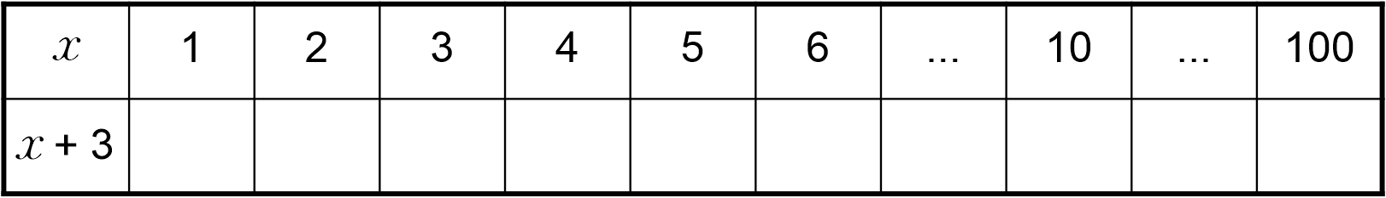
NPA6

Extend and apply the laws and properties of arithmetic to algebraic terms and expressions
- Generalise the associative property of addition and multiplication to algebraic expressions
Example(s):
Generalising associativity for numbers such as: $$\left(3+5\right)+2=3+\left(5+2\right)$$, to algebraic expressions such as $$\left(a+b\right)+c=a+\left(b+c\right)$$, and generalising associativity for numbers such as $$\left(3×4\right)×2=3×\left(4×2\right)$$, to algebraic expressions such as $$\left(ab\right)×c=a×\left(bc\right)=abc$$.
NPA7
- Generalise the commutative property to algebraic expressions
Example(s):
Generalising commutativity for numbers such as: $$3+5=5+3$$ to algebraic expressions such as $$a+b=b+a$$, generalising commutativity for numbers such as $$3×4=4×3$$ to algebraic expressions such as $$ba = ab$$.
NPA7
- Identify like terms, and add and subtract them to simplify algebraic expressions
NPA7
- Simplify algebraic expressions that involve multiplication and division, including simple algebraic fractions
Example(s):
Simplifying algebraic expressions such as $$12a÷3, 4x×3, 2ab×3a, \frac{8a}{2}\text{,} \frac{2a}{8} and \frac{12a}{9}$$.
NPA7
- Simplify algebraic expressions involving mixed operations
Example(s):
Simplifying algebraic expressions such as $$a×4+3÷b-2×a$$.
NPA7

Extend and apply the distributive law to the expansion of algebraic expressions
- Explain the role and meaning of grouping symbols in algebraic expressions
Example(s):
Generalising the distributive law for numbers such as: $$3×\left(20+7\right)=3×20+3×7$$ to algebraic expressions such as $$a\left(b+c\right)=ab+ac$$.
Showing, using an area model, that $$a\left(b+c\right)=ab+ac$$.
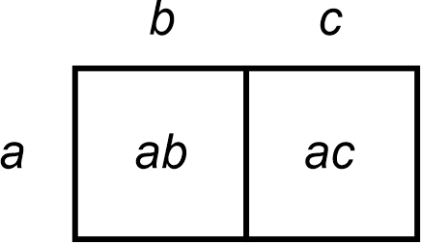
NPA7
- Apply the distributive law to expand and simplify algebraic expressions by removing grouping symbols
Example(s):
Expanding algebraic expressions such as $$3\left(a+2\right)$$, $$-5\left(x+2\right)$$, $$a\left(a+b\right)$$ and $$x\left(-x-2\right)$$.
NPA7

Factorise algebraic expressions by identifying numerical and algebraic factors
- Identify and list factors of a single term
Example(s):
Identifying the factors of $$6x$$ as $$1$$, $$2$$, $$3$$, $$6$$, $$x$$, $$2x$$, $$3x$$, $$6x$$, $$-1$$, $$-2$$, $$-3$$, $$-6$$, $$-x$$, $$-2x$$, $$-3x$$ and $$-6x$$.

- Factorise algebraic expressions using knowledge of factors and finding the highest common numerical factor (HCF)
Example(s):
Factorising expressions such as $$4x-8=4\left(x-2\right)$$.
NPA7
- Factorise algebraic expressions using knowledge of factors by finding a common algebraic factor, including expressions involving more than 2 terms, and verify the result by expansion
Example(s):
Factorising expressions such as $$32y^{2}-16xy$$.
NPA7

Indices

Outcomes
A student:
- develops understanding and fluency in mathematics through exploring and connecting mathematical concepts, choosing and applying mathematical techniques to solve problems, and communicating their thinking and reasoning coherently and clearly MAO-WM-01
- operates with primes and roots, positive-integer and zero indices involving numerical bases and establishes the relevant index laws MA4-IND-C-01

Content

Apply index notation to represent whole numbers as products of powers of prime numbers
- Describe numbers written in index form using terms such as base, power, index and exponent
Example(s):
Representing a number with a base of 5 and an index of 2.

- Represent numbers in index notation limited to positive powers
Example(s):
Expressing 2, 4, 8, 16 and 32 as powers of 2.
MuS9
- Represent in expanded form and evaluate numbers expressed in index notation, including powers of 10
Example(s):
Explaining that 10³ $$=$$ 10 $$×$$ 10 $$×$$ 10 $$=$$ 1000.
Examining and generalising the sign of the result when a negative number is raised to an odd or even power.
MuS9
- Apply the order of operations to evaluate expressions involving indices
Example(s):
Evaluating $$3^{2}+4^{2}$$ , $$4^{3}+2×5^{2}$$.

- Determine and apply tests for divisibility for 2, 3, 4, 5, 6 and 10
Example(s):
Finding the smallest number that is greater than 1000 and is divisible by 6.

- Represent a whole number greater than one as a product of its prime factors, using index notation where appropriate
Example(s):
Representing 324 as 2 $$×$$ 2 $$×$$ 3 $$×$$ 3 $$×$$ 3 $$×$$ 3 $$=$$ 2² $$×$$ 3⁴.
MuS9

Examine cube roots and square roots
- Use the notations for square root ( ) and cube root ($$\sqrt[3]{ }$$)
Example(s):
Evaluating $$\sqrt[3]{8}$$ and $$3\sqrt{8}$$ and explaining why they are different.

- Recognise and describe the relationship between squares and square roots, and cubes and cube roots for positive numbers
Example(s):
Deducing that if $$7^{2}=49$$, then $$\sqrt{49}=7$$ and if $$5^{3}=125$$, then $$\sqrt[3]{125}=5$$.

- Verify, through numerical examples, that $$\sqrt{ab}=\sqrt{a}×\sqrt{b}$$
Example(s):
Showing that if $$\sqrt{9×4}=\sqrt{36}=6$$ and $$\sqrt{9}×\sqrt{4}=3×2=6$$, then $$\sqrt{9×4}=\sqrt{9}×\sqrt{4}$$.

- Estimate the square root of any non-square whole number and the cube root of any non-cube whole number, then check using a calculator
Example(s):
Estimating the value of $$\sqrt{30}$$ by first considering that it lies between $$\sqrt{25}$$ and $$\sqrt{36}$$ .
Creating a true statement with the smallest possible interval of the form: $$□.□□<\sqrt{6}<□.□□$$using the digits 1 to 6, at most one time each.

- Identify and describe exact and approximate solutions in the context of square roots and cube roots
- Apply the order of operations to evaluate expressions involving square roots, cube roots, square numbers and cube numbers
Example(s):
Finding the missing numbers to make the number sentence true: $$\left[{3×□}^{2}+\left(\sqrt{25}-□\right)\right]=\sqrt{□}×9×3-5$$.

Use index notation to establish the index laws with positive-integer indices and the zero index
- Establish the multiplication, division and the power of a power index laws, by expressing each number in expanded form with numerical bases and positive-integer indices
Example(s):
Recognising that $$3^{2}×3^{4}=\left(3×3\right)×\left(3×3×3×3\right)=3^{6}=3^{2 + 4}$$, and generalising this into the form $$a^{m}×a^{n}=a^{m + n}$$.
Recognising that $$3^{5}÷3^{2}=\frac{3 × 3 × 3 × 3 × 3}{3 × 3}=3^{3}=3^{5 - 2}$$, and generalising this into the form $$a^{m}÷a^{n}=a^{m - n}$$.
Recognising that $${\left(3^{4}\right)}^{2}=3^{4}×3^{4}=3×3×3×3×3×3×3×3=3^{8}$$, and generalising this into the form $${\left(a^{m}\right)}^{n}=a^{m × n}$$.

- Verify through numerical examples that $${\left(ab\right)}^{2}=a^{2}b^{2}$$
- Establish the meaning of the zero index
Example(s):
Establishing the meaning of the zero index using index laws such as: $$\frac{5^{2}}{5^{2}}=\frac{25}{25}=1$$, and $$\frac{5^{2}}{5^{2}}=5^{2 - 2}=5^{0}$$, $$∴5^{0}=1$$.
Exploring the pattern $$2^{4}, 2^{3}, 2^{2}, 2^{1}, 2^{0}$$.

- Apply index laws to simplify and evaluate expressions with numerical bases
Example(s):
Evaluating $$5^{2}×5^{4}×5$$, $$4^{6}÷4^{3}×4^{2}$$ and $${\left(4^{0}×3^{3}÷3^{4}\right)}^{2}$$.

Equations

Outcomes
A student:
- develops understanding and fluency in mathematics through exploring and connecting mathematical concepts, choosing and applying mathematical techniques to solve problems, and communicating their thinking and reasoning coherently and clearly MAO-WM-01
- solves linear equations of up to 2 steps and quadratic equations of the form $${ax}^{2}=c$$ MA4-EQU-C-01
Related Life Skills outcomes: MALS-ADS-01, MALS-MDI-01

Content

Solve linear equations up to 2 steps
- Represent number sentences involving unknown quantities using pronumerals
Example(s):
Explore how Aboriginal and/or Torres Strait Islander Peoples may use storytelling and/or dance to represent mathematical equations.
NPA6, NPA7
- Describe number sentences as equations
- Distinguish between and compare algebraic expressions and equations
NPA7
- Solve linear equations with integer and non-integer solutions using algebraic techniques that involve up to 2 steps, including equations with pronumerals on both sides
Example(s):
Solving $$2x+5=20$$, $$8-3x=-20$$, $$23=\frac{x}{3}+26$$, $$\frac{x + 4}{3}=2$$ and$$2x+3=4x$$.

- Model and solve word problems using equations of up to 2 steps
NPA7

Solve and verify linear equations by substitution
- Verify solutions to equations by substitution
Example(s):
Verifying that $$x=7.5$$is a solution by substituting in the equation $$\frac{2x}{3}+5=10$$.
$$LHS=\frac{2×7.5}{3}+5$$
$$=\frac{15}{3}+5$$
$$=5+5$$
$$=10$$
$$=RHS$$
NPA6
- Solve problems involving linear equations, including those arising from substituting given values into formulas
Example(s):
Recognising that 2 consecutive integers can be represented as $$x$$ and $$x+1$$, and use these to find 2 consecutive integers that have a sum of 23.
Finding the value of $$t$$ in the formula $$v=u+at$$ if $$v=10$$, $$u=3$$ and $$a=2$$.
Finding the value of $$x$$ if a rectangle with length $$(2x-1)$$cm and width 3 cm has an area of 39 cm².
NPA7, NPA8

Solve quadratic equations
- Reason why there are 2 values of $$x$$ that satisfy a quadratic equation of the form $$x^{2}=c$$ if $$c>0$$
Example(s):
Evaluating $$3^{2}$$ and $${\left(-3\right)}^{2}$$and solving $$x^{2}=9$$ and explaining why there is no solution to $$x^{2}=-9$$.

- Solve problems involving quadratic equations of the form $$ax^{2}=c$$, giving answers in exact form and as decimal approximations
Example(s):
Explaining that if $$x^{2}=5$$, then $$x$$ can be expressed in exact form as $$x=±\sqrt{5}$$ or as a decimal approximation as $$x≈±2.24$$ to 2 decimal places.

- Solve quadratic equations arising from substitution into a formula
Example(s):
Finding the value of $$r$$ in the formula $$A={πr}^{2}$$ if $$A=10.$$
NPA8

Linear relationships

Outcomes
A student:
- develops understanding and fluency in mathematics through exploring and connecting mathematical concepts, choosing and applying mathematical techniques to solve problems, and communicating their thinking and reasoning coherently and clearly MAO-WM-01
- creates and displays number patterns and finds graphical solutions to problems involving linear relationships MA4-LIN-C-01
Related Life Skills outcomes: MALS-POS-01

Content

Plot and identify points on the Cartesian plane
- Plot and label points on the Cartesian plane of given coordinates, including those with coordinates that are not whole numbers
Example(s):
Plotting and labelling the points $$P\left(\frac{1}{3}, -2\right)$$ and $$Q(-3.5,0)$$on the Cartesian plane.
Aboriginal art uses topographical views to map Country. Use a topographical map of the local region to identify coordinates of landmarks such as watering holes, cultural places or places of personal significance.
NPA8
- Identify and record the coordinates of given points on the Cartesian plane, including those with coordinates that are not whole numbers
Example(s):
Using the diagram of the Cartesian plane to identify the coordinates of point A, naming the point at $$\left(4, -2\frac{1}{2}\right)$$, labelling point Z on the $$x$$-axis directly above point C, and identifying the coordinates of the point $$2\frac{1}{2}$$ units left of the origin.
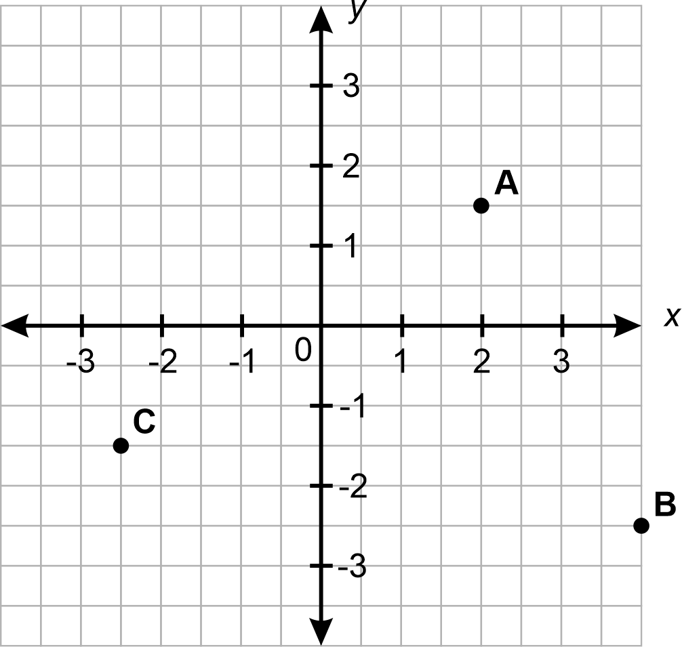
Image long description: A number plane with an $$x$$ and $$y$$-axis. Point A is plotted at 2, 1.5. Point B is plotted at 4, minus 2.5. Point C at minus 2.5, minus 1.5
PoL5

Plot linear relationships on the Cartesian plane
- Construct a geometric pattern and record the results in a table of values
Example(s):
Representing the pattern below made from matches in a table of values:
Image long description: The number of pentagons is measured against the number of matches used to make the pentagon pattern, represented in a table. The table shows the number of pentagons on the top row (1, 2, 3, 4) and the corresponding number of matches on the bottom row (5, 9, blank, 17).

- Represent a given number pattern (including decreasing patterns) using a table of values
NPA5
- Describe a number pattern in words and generate an equation using algebraic symbols
Example(s):
Describing a number pattern as: the $$y$$-value is double the $$x$$-value, and generalising the equation to be $$y=2x$$.
NPA7
- Apply an equation generated from a pattern to calculate the corresponding value for a smaller or larger number
Example(s):
Generating the equation for the pattern and completing the table of values.
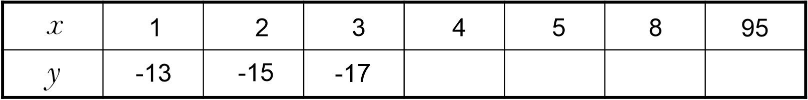
Image long description: A table with $$x$$-values on the top row (1, 2, 3, 4, 5, 8, 95) and $$y\text{-}$$values on the bottom row (minus 13, minus 15 and minus 17). The remaining values for $$y$$ are left blank.
NPA7
- Recognise that a linear relationship can be represented by a number pattern, an equation (or a rule using algebraic symbols), a table of values, a set of pairs of coordinates and a line graphed on a Cartesian plane, and move flexibly between these representations
Example(s):
Deriving the equation representing the relationship between $$x$$ and $$y$$ by completing a table of values for the set of points shown in the diagram.
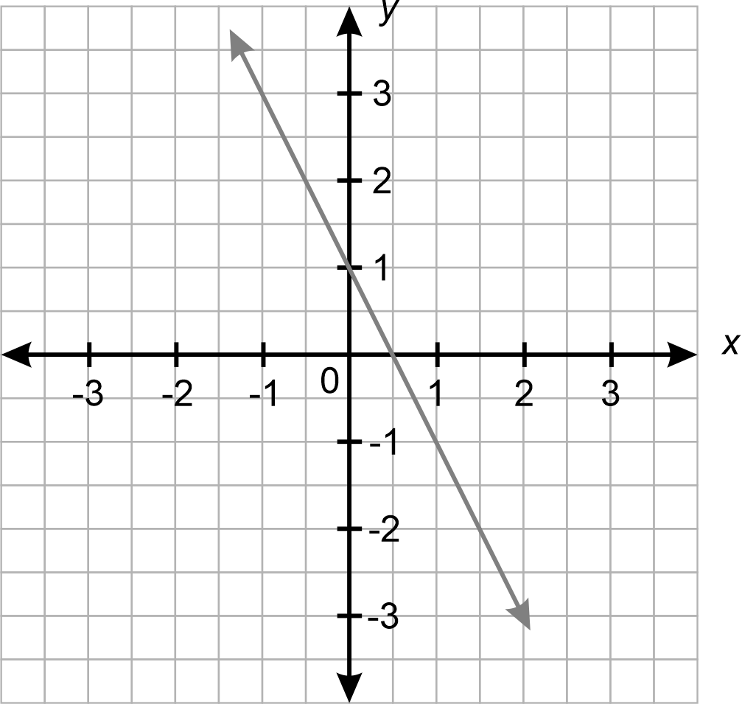
NPA7, NPA8
- Explain that there are an infinite number of ordered pairs that satisfy a given linear relationship by extending a line joining a set of points on the Cartesian plane
- Compare similarities and differences of multiple straight-line graphs on the same set of axes using graphing applications
Example(s):
Using digital tools to graph $$y=x+1$$, $$y=x-2$$ and $$y=-2x+1$$ on the same Cartesian plane, identifying similarities and differences such as parallel, non-parallel, pass through the same point, increasing and decreasing.

- Describe linear relationships in real-life contexts and solve related problems
Example(s):
Demonstrating a linear relationship using a graph for a situation where an electrician charges a $75 call-out fee and $60 for each hour it takes to complete a job.
NPA8, IRD6

Solve linear equations using graphical techniques
- Recognise that each point on the graph of a linear relationship satisfies the equation of a line
Example(s):
Verifying that the points $$\left(2, 5\right)$$ and $$\left(-1, -1\right)$$ satisfy the line $$y=2x+1$$.

- Apply graphs of linear relationships to solve a corresponding linear equation using graphing applications
Example(s):
Using the graph of $$y=2x+3$$ to find the solution to the equation $$2x+3=11$$.
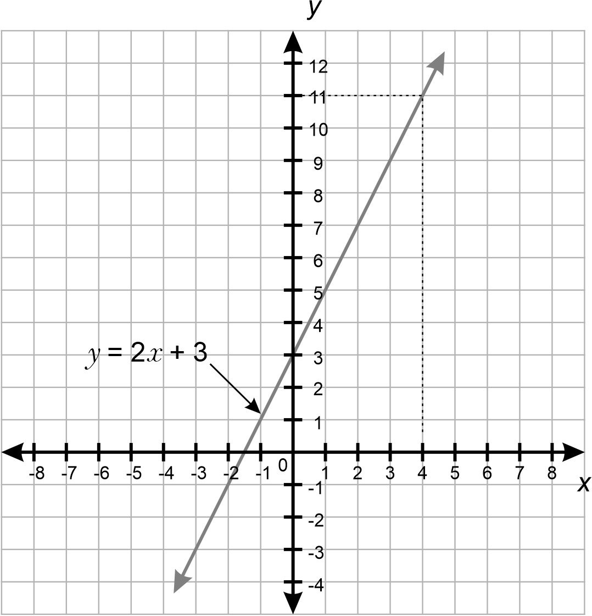
IRD6
- Graph 2 intersecting lines on the same set of axes and identify the point of intersection using either graphing applications or a table of values
Example(s):
Graphing the linear equations $$y=2x+1$$ and $$y=-x+4$$ and identifying their point of intersection.
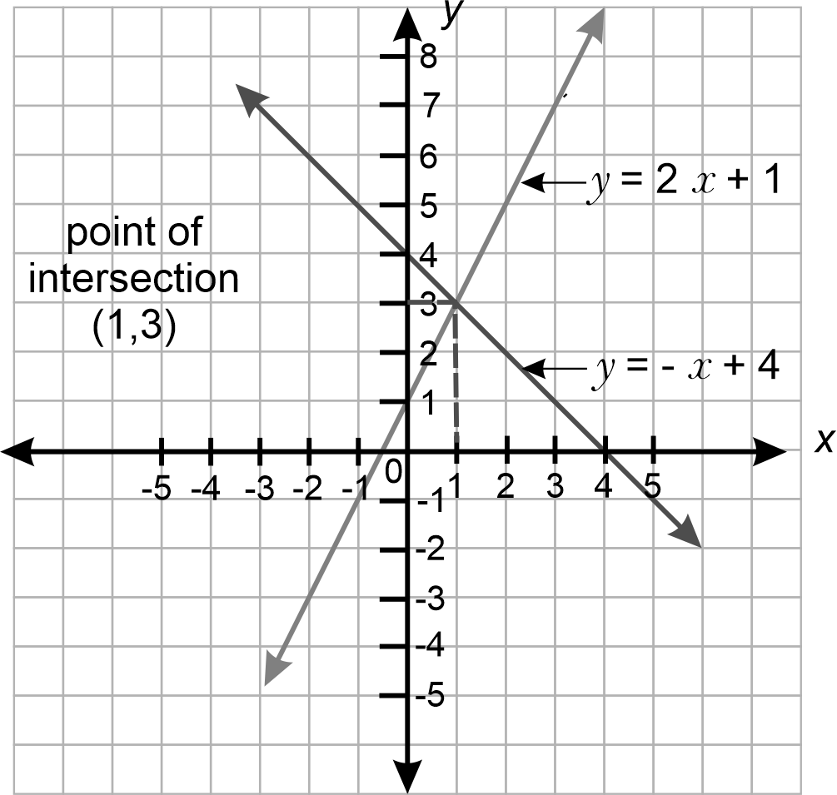

- Verify that the point of intersection satisfies the equations of both lines

Length

Outcomes
A student:
- develops understanding and fluency in mathematics through exploring and connecting mathematical concepts, choosing and applying mathematical techniques to solve problems, and communicating their thinking and reasoning coherently and clearly MAO-WM-01
- applies knowledge of the perimeter of plane shapes and the circumference of circles to solve problems MA4-LEN-C-01
Related Life Skills outcomes: MALS-LEN-01

Content

Solve problems involving the perimeter of various quadrilaterals and simple composite figures
- Solve problems involving the perimeter of plane shapes, including parallelograms, trapeziums, rhombuses and kites
Example(s):
Finding the perimeter of irregular plane shapes such as:
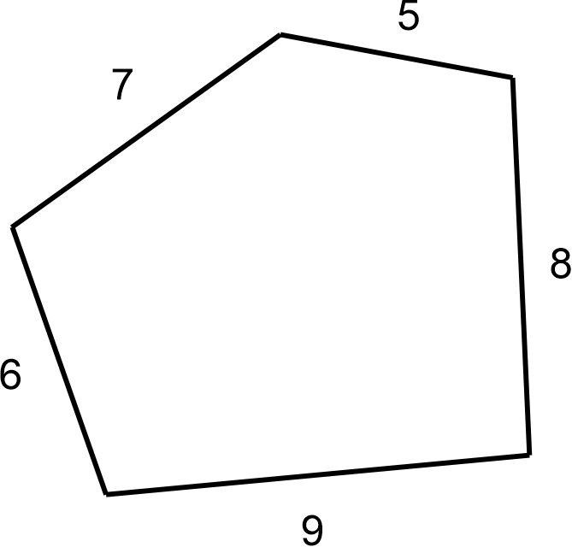
UuM7, UGP6
- Solve problems relating to the perimeter of simple composite figures
UuM7, UGP6
- Compare methods of solution for finding perimeter and evaluate the efficiency of those methods
Example(s):
Analysing different ways a perimeter could be found.
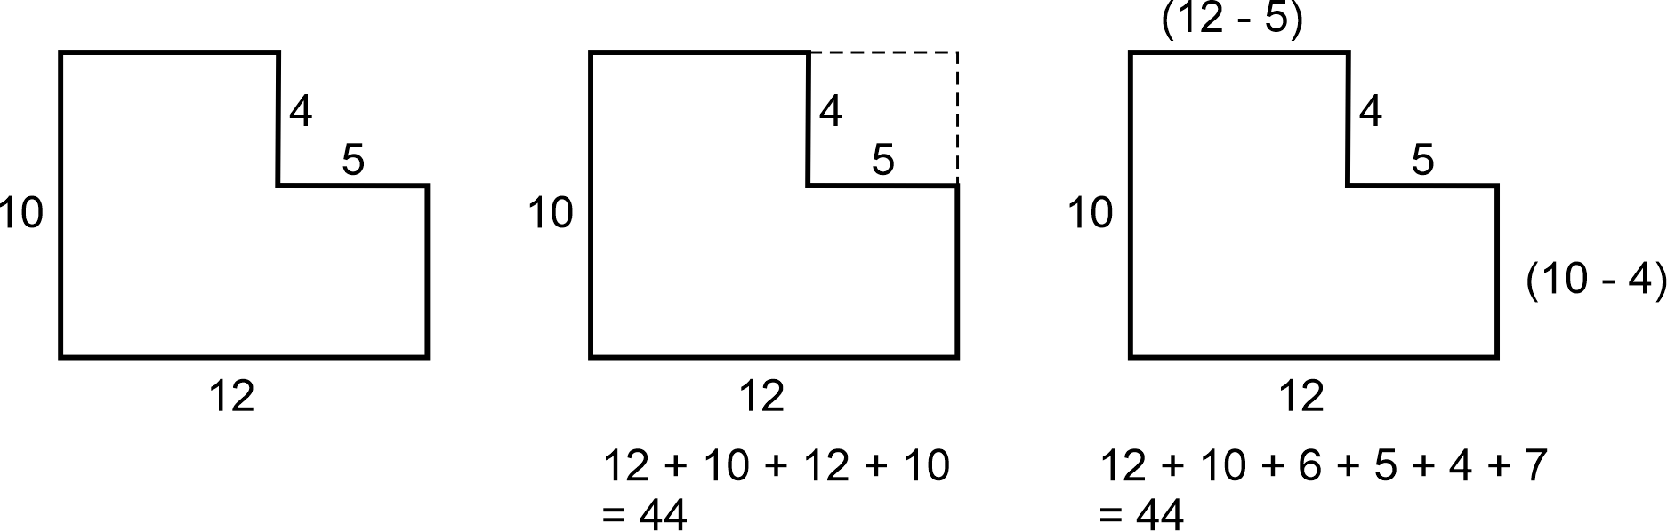
Image long description: The composite shape is a rectangle with a section missing. The intact height of the shape is labelled 10 and the width is labelled 12. The missing section height is 4 and the width 5. The first way to find the perimeter is to extend the missing section’s height and width to create the equation: 12 plus 10, plus 12, plus 10 equals 44. The second way to find the perimeter is to subtract the missing section’s height and width from the rectangle’s height and width to find the length of the shortened sides, and add this to the height and width of the rectangle and missing sections. This forms the equation: 12 plus 10, plus 6, plus 5, plus 4, plus 7 equals 44.

Describe the relationships between the features of circles
- Identify and describe the relationship between circle features, including the radius, diameter, arc, chord, sector and segment of a circle, and a tangent to a circle
- Define $$π$$ as the ratio of the circumference to the diameter of any circle
Example(s):
Comparing values for the ratio of the circumference to the diameter by measuring the diameter and circumference of a variety of circles and/or cylinders.
UuM9
- Verify that the number$$π$$ is a constant and develop the formula for the circumference of a circle
UuM9
- Apply the formula for the circumference of a circle in terms of the diameter $$d$$ or radius $$r$$ (circumference of a circle $$=πd$$ or $$2πr$$) to solve related problems to solve related problems
Example(s):
Calculating the inner circumference of several yidakis (didgeridoos) and examining how the inner circumference affects the sound produced.
UuM9, NPA8, UGP6
- Establish the arc length formula $$\left(l=\frac{θ}{360}×2πr\right)$$ where $$l$$ is the arc length and $$θ$$ is the angle subtended at the centre by the arc
UuM9, NPA8, UGP6
- Solve problems by finding arc lengths and the perimeter of sectors, giving an exact answer in terms of $$π$$ or an approximate answer
Example(s):
Calculating the approximate distance between 2 locations on the equator using an assumed value for the Earth’s radius.
UuM9, NPA8, UGP6
- Find the perimeter of quadrants, semicircles and simple composite figures consisting of 2 shapes in a variety of contexts, including using digital tools
Example(s):
Using online mapping applications to calculate the perimeter of places of interest, such as a local running track or botanical garden.
UuM9, NPA8, UGP6

Right-angled triangles (Pythagoras’ theorem)

Outcomes
A student:
- develops understanding and fluency in mathematics through exploring and connecting mathematical concepts, choosing and applying mathematical techniques to solve problems, and communicating their thinking and reasoning coherently and clearly MAO-WM-01
- applies Pythagoras’ theorem to solve problems in various contexts MA4-PYT-C-01

Content

Identify and define Pythagoras’ theorem
- Identify and describe the hypotenuse as the side opposite the right angle and the longest side in any right-angled triangle
Example(s):
Analysing right-angled triangles of differing sizes and orientations and identifying the hypotenuse.
UGP6
- Establish the relationship between the lengths of the sides of a right-angled triangle
Example(s):
Rearranging 4 congruent right-angled triangles of side lengths a, b and c to form a square with a side length $$a+b$$ and establishing the relationship between the lengths of the sides of a right-angled triangle.
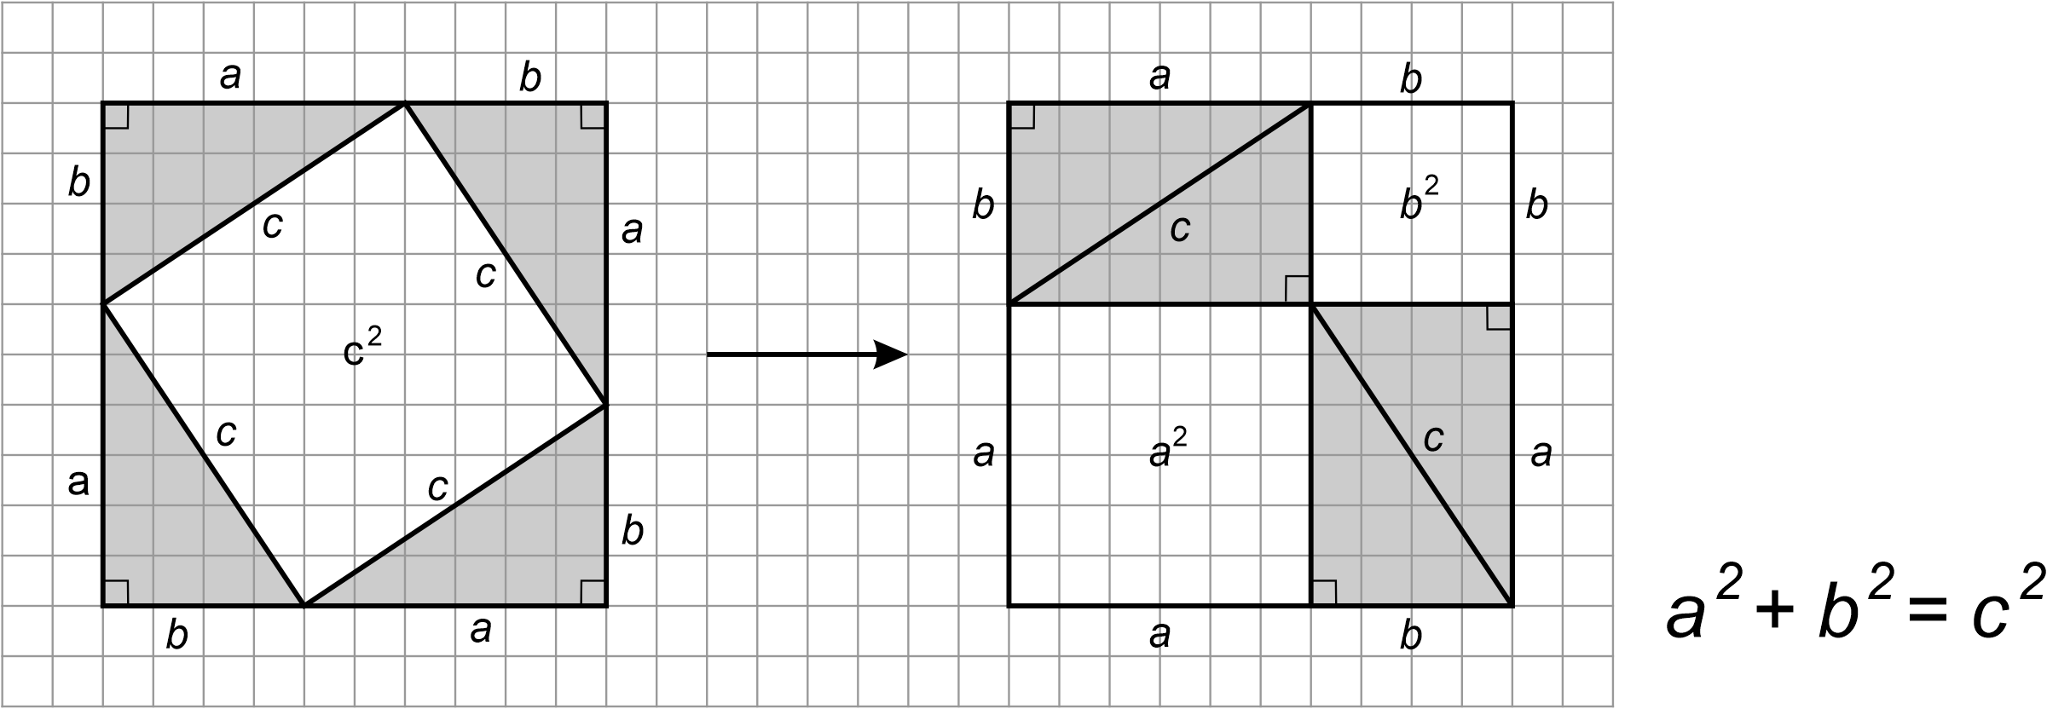
Image long description: The first square has a side length of $$a$$ plus $$b$$, and has a square of side length $$c$$ at a diagonal rotation inside it. The second square represents how this creates a square of side length $$a$$ plus $$b$$, with 2 identical rectangles of diagonal length $$c$$ and squares of side length $$a$$ and side length $$b$$ inside the larger square.
UGP6, NPA6
- Use the relationship to record and define Pythagoras’ theorem both algebraically and in words
UGP6, NPA8

Examine problems involving Pythagoras’ theorem
- Apply Pythagoras’ theorem to find the unknown length of a side in a right-angled triangle, giving answers in an exact form or as decimal approximations
Example(s):
Reasoning why the negative solution of the relevant quadratic equation is not feasible when solving problems involving Pythagoras’ theorem.
NPA8, UuM10, UGP7
- Apply the converse of Pythagoras’ theorem to establish whether a triangle is right angled
Example(s):
Justifying that a triangle with side lengths of 5 m, 12 m and 13 m is right-angled.
UGP6
- Solve practical problems involving Pythagoras’ theorem before exploring a variety of related problems
Example(s):
Exploring the possible areas of a rhombus with a side length of 8 cm and one diagonal length of 15 cm.
NPA8, UuM10, UGP7
- Justify whether a set of 3 integers is a Pythagorean triad
UGP7

Area

Outcomes
A student:
- develops understanding and fluency in mathematics through exploring and connecting mathematical concepts, choosing and applying mathematical techniques to solve problems, and communicating their thinking and reasoning coherently and clearly MAO-WM-01
- applies knowledge of area and composite area involving triangles, quadrilaterals and circles to solve problems MA4-ARE-C-01
Related Life Skills outcomes: MALS-ARE-01

Content

Develop and use formulas to find the area of rectangles, triangles and parallelograms to solve problems
- Apply the formula to find the area of a rectangle or square: $$A=lb$$, where $$l$$ is the length and $$b$$ is the breadth (or width) of the rectangle or square
Example(s):
Comparing various rectangles with the same area and examining whether they have the same perimeter, such as finding the possible perimeters of all rectangles with integer side lengths that have an area of 36 cm².
UuM8, NPA8
- Develop and apply the formula to find the area of a triangle: $$A=$$ $$\frac{1}{2}bh$$, where $$b$$ is the base length and $$h$$ is the perpendicular height
Example(s):
Verifying the formula for the area of a triangle by folding a rectangle in half to see that the area of the triangle is half that of the rectangle.
Identifying the perpendicular height of triangles in different orientations and verifying that triangles with the same base length and height have equal areas by using digital tools.
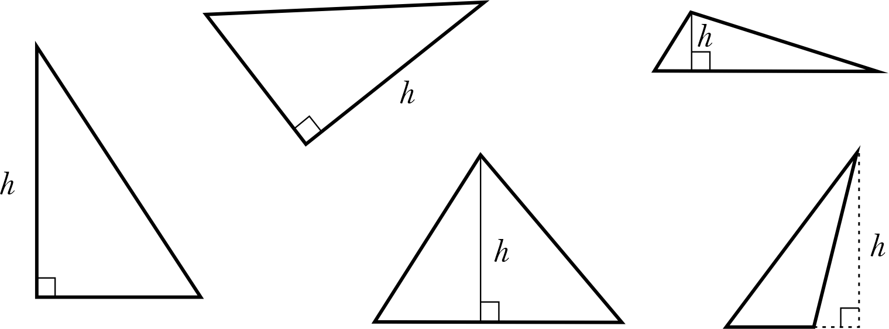
UuM8
- Develop and apply the formula to find the area of a parallelogram: $$A=$$ $$bh$$ where$$b$$is the base length and $$h$$ is the perpendicular height
Example(s):
Developing the formula for the area of a parallelogram by either rotating a right-angled triangle or bisecting a pair of opposite sides of a parallelogram and rotating the triangles to form a rectangle.
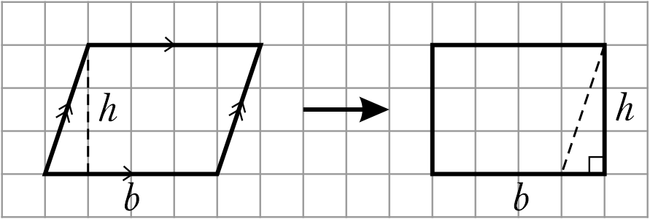
Image long description: A parallelogram showing perpendicular height h and side length b, transformed into a rectangle by using the perpendicular height as the width of the rectangle, and the length of the parallelogram as the length of the rectangle.
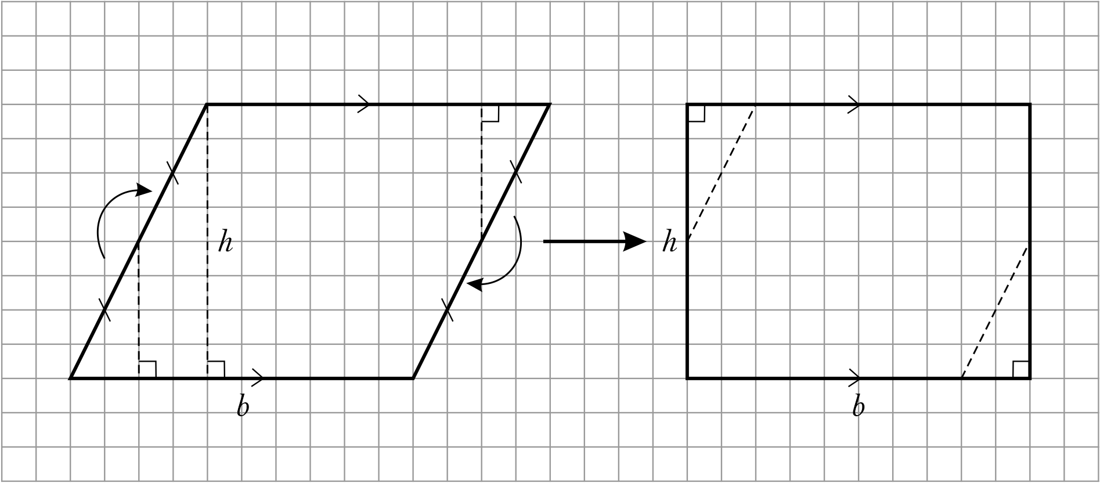
Image long description: A parallelogram transformed into a rectangle, demonstrating how a triangle on the edge of the parallelogram can be flipped to form a rectangle of the same dimensions.
UuM9, NPA8
- Calculate the area of composite figures that can be dissected into rectangles, squares, parallelograms or triangles to solve problems
Example(s):
Exploring different ways to find composite areas.
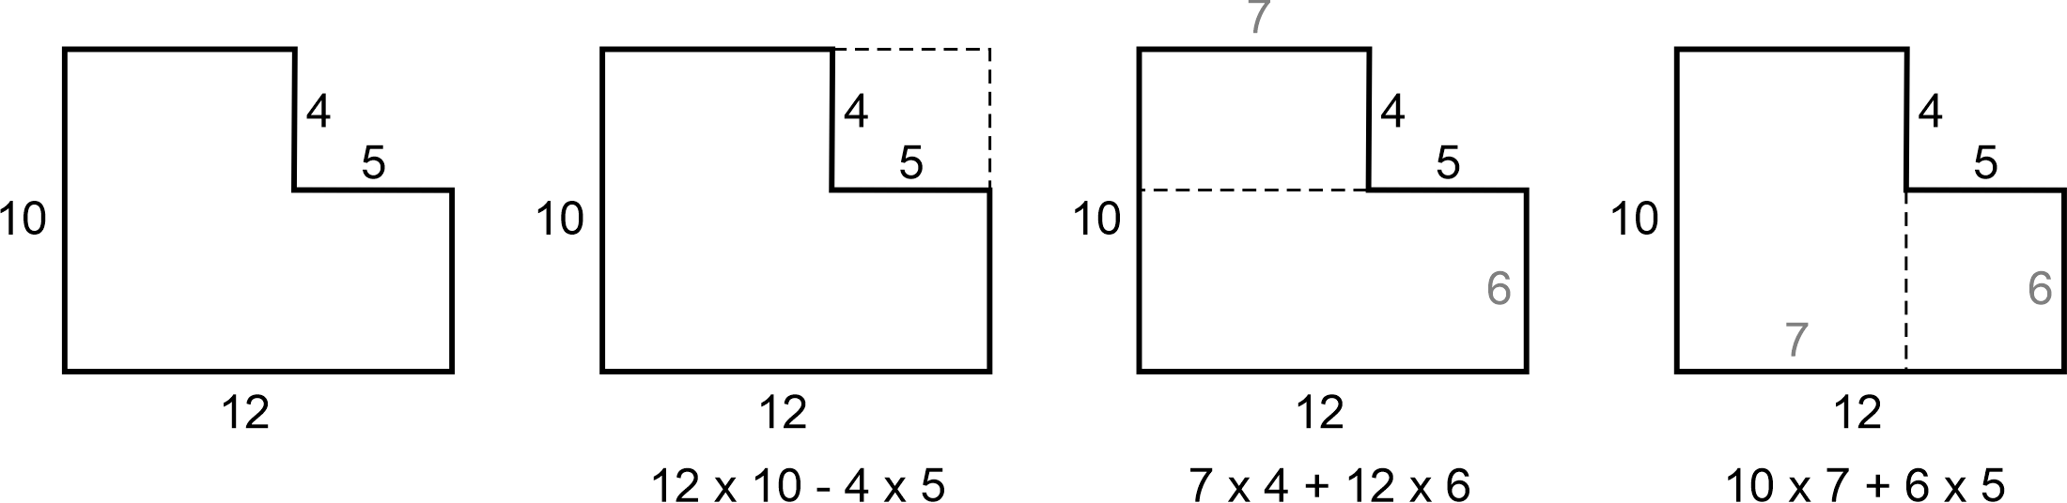
Image long description: The first diagram shows that the composite shape is 2 rectangles. The large rectangle has a width of 6 and length of 12, the other has a width of 4 and length of 7. They are joined together so the shape is a rectangle with a corner missing. The second diagram shows that the area can be found by first finding the total area of the shape and subtracting the missing section with the equation: 12 multiplied by 10, minus 4 multiplied by 5. The third diagram shows that the area can be found by adding the total areas of the 2 rectangles when split horizontally. The equation is 7 multiplied by 4, plus 12 multiplied by 6. The fourth diagram shows that the area can be found by adding the total areas of the 2 rectangles when split vertically. The equation is 10 multiplied by 7, plus 6 multiplied by 5.
UuM10

Develop and use the formula to find the area of circles and sectors to solve problems
- Develop and apply the formula to find the area of a circle: $$A=πr^{2},$$ where $$r$$ is the length of the radius
Example(s):
Developing the formula to find the area of a circle by dissecting a circle into many congruent sectors and arranging them to form an approximate parallelogram with height r and base $$πr$$ and considering the area of the parallelogram.
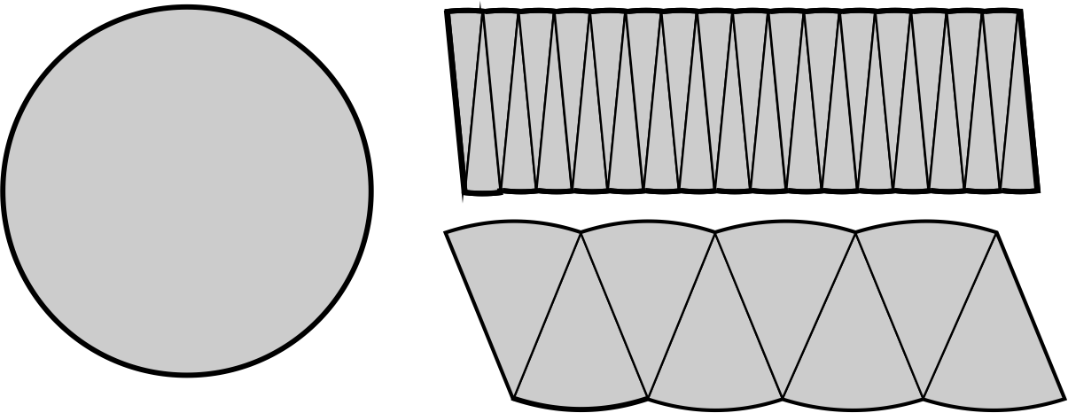
Image long description: A circle is broken up into 8 sectors which are placed together to create the third shape. The second shape is created using 32 sectors of the same circle arranged in a tight line to indicate how the smaller the size of the sectors, the closer the shape becomes to a parallelogram.
UuM9, NPA8
- Explain how the area of a sector can be developed from the area of a circle $$\left(A=\frac{θ}{360}×πr^{2}\right)$$
UuM9, NPA8
- Find the area of quadrants, semicircles and sectors, and apply these formulas in the context of real-life problems
Example(s):
Measuring and calculating the area inside the 3-point line of a basketball court.
UuM9, NPA8, UGP6
- Calculate the areas of composite shapes involving quadrants, semicircles and sectors to solve problems
UuM9, NPA8, UGP6

Develop and use the formulas to find the area of trapeziums, rhombuses and kites to solve problems
- Develop and apply the formula to find the area of a kite or rhombus: $$A=\frac{1}{2}xy,$$ where $$x$$ and $$y$$ are the lengths of the diagonals
Example(s):
Developing the area of a rhombus or kite by dividing the shape on the diagonals into 2 or 4 right-angled triangles:
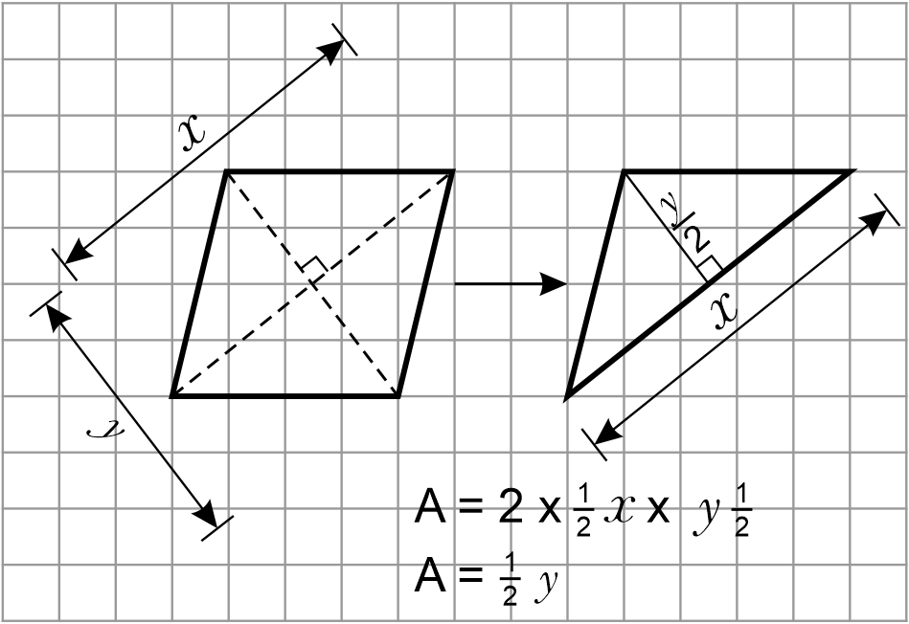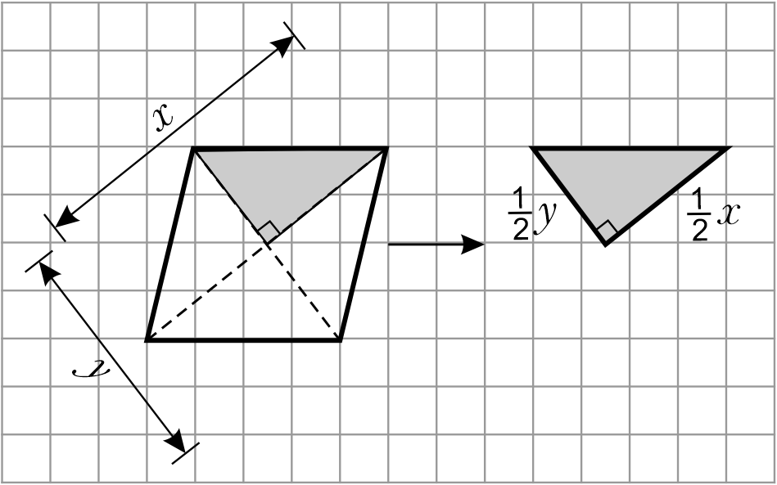
$$A=4×\frac{1}{2} ×\frac{1}{2}x × \frac{1}{2}y= \frac{1}{2}xy$$
Image long description: Demonstration of how a rhombus with one diagonal measuring $$x$$ and one diagonal measuring $$y$$ becomes a triangle with perpendicular height $$y$$ over 2 and base length $$x$$.
UuM9, NPA8
- Develop and apply the formula to find the area of a trapezium: $$A=\frac{h}{2}\left(a+b\right),$$ where $$h$$ is the perpendicular height and $$a$$ and $$b$$ are the lengths of parallel sides
Example(s):
Developing the formula for the area of a trapezium by bisecting the non-parallel sides, dissecting the trapezium and rotating triangles to form a rectangle with the same perpendicular height and length as half of the sum of the 2 parallel sides.
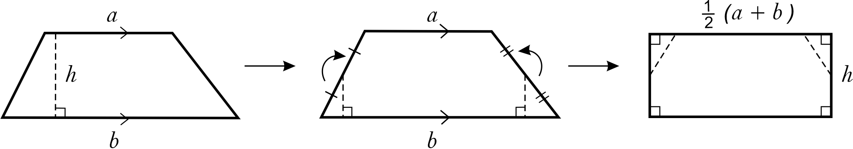
Image long description: Trapezium with parallel sides a and b, and perpendicular height h. Triangles on either end are flipped upwards to form a rectangle with side length of a half multiplied by a plus b, and width h.
UuM9, NPA8
- Calculate the area of composite shapes involving trapeziums, kites and rhombuses to solve problems
UuM9, NPA8, UGP6

Choose appropriate units of measurement for area and convert between units
- Choose an appropriate unit to measure the area of different shapes and surfaces, and justify the choice
Example(s):
Examining the suitability of units relative to the size of an object, based on real-life scenarios such as the area of a paddock in hectares, the area of a local botanical garden in km² or the floor space of a hall in m².

- Convert between metric units of area using $${1 cm}^{2}=100 {mm}^{2}$$, $$1 m^{2}=10 000 {cm}^{2}$$, $$1 ha=10 000 m^{2}$$ and $$1 {km}^{2}=1 000 000{ m}^{2}=100 ha$$
Example(s):
Representing conversions using areas of squares.
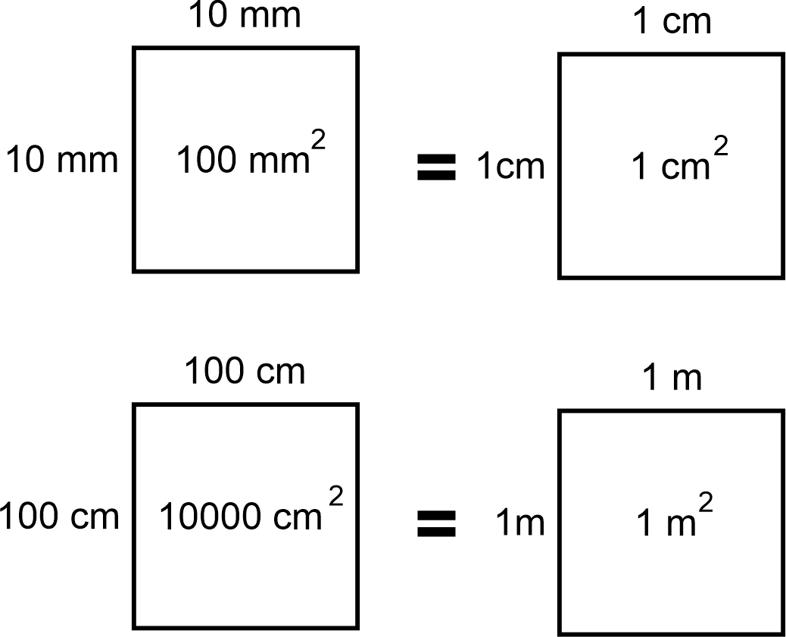
Image long description: The first square has sides of 10 millimetres with an area of 100 square millimetres. It is equal to the second square that has sides of 1 centimetre and an area of 1 square centimetre. The third square has sides of 100 centimetres and an area of 10 000 square centimetres. It is equal to the fourth square with sides of 1 metre and an area of 1 square metre.
UuM8

Volume

Outcomes
A student:
- develops understanding and fluency in mathematics through exploring and connecting mathematical concepts, choosing and applying mathematical techniques to solve problems, and communicating their thinking and reasoning coherently and clearly MAO-WM-01
- applies knowledge of volume and capacity to solve problems involving right prisms and cylinders MA4-VOL-C-01
Related Life Skills outcomes: MALS-VOL-01

Content

Describe the different views of prisms and solids that have been formed from prism combinations
- Represent prisms from different views in 2 dimensions, including top, side, front and back views
UGP5
- Describe and illustrate solids formed from prism combinations from different views in 2 dimensions, including top, side, front and back views
Example(s):
Illustrating different perspectives of solids consisting of combinations of prisms created using digital tools or concrete materials.
UGP5
- Identify and illustrate the cross-sections of different prisms
UGP5
- Examine the idea that prisms have a uniform cross-section that is equal to the base area
UGP5
- Determine if a particular solid has a uniform cross-section
UGP5

Develop and apply the formula to find the volume of a prism to solve problems
- Develop the formula for the volume of a prism: $$V=base area×height$$, leading to $$V=Ah$$
UuM9
- Apply the formula for the volume of a prism to prisms with uniform cross-sections to solve problems
Example(s):
Calculating the side length of a cube with a volume of 125 cm³.
UuM9, NPA8, UGP6

Develop the formula for finding the volume of a cylinder and apply the formula to solve problems
- Develop and apply the formula to solve problems involving the volume of cylinders: $$V=πr^{2}h,$$ where $$r$$ is the length of the radius of the base and $$h$$ is the perpendicular height
Example(s):
Developing the formula for finding the volume of a cylinder by recognising repeated layers of circles.
Calculating the volume of wood eaten by termites to create an emu caller (hollow cylinder) assuming they are perfect cylinders.
UuM9, NPA8

Choose appropriate units of measurement for volume and capacity and convert between units
- Recognise that 1000 L is equal to 1 kilolitre (kL) and use the abbreviation
UuM8
- Recognise that 1000 kL is equal to 1 megalitre (ML) and use the abbreviation
Example(s):
Recognising the use of kL and ML in estimating the volume of real-life situations such as Sydney Harbour, a local dam or a backyard swimming pool.
UuM8
- Choose an appropriate unit to measure the volume or capacity of different objects and justify the choice
Example(s):
Identifying the most appropriate units to measure the capacity of a swimming pool or a fish tank.
Using the capacities of familiar containers to help estimate the capacity of larger containers.

- Convert between metric units of volume and capacity ($$\text{1 }{\text{cm}}^{\text{3 }}\text{= 1000}{ \text{mm}}^{\text{3}}$$, $$\text{1 }{\text{cm}}^{\text{3}}\text{ = 1 }\text{mL}$$, $$\text{1}{ \text{m}}^{\text{3}}\text{ = 1000 }\text{L }\text{= 1 }\text{kL}$$, $$\text{1000 }\text{kL }\text{= 1 }\text{ML}$$)
UuM8, UuM10
- Solve practical problems involving the volume and capacity of right prisms and cylinders
Example(s):
Given the volume of carrying tools used by Aboriginal Peoples, demonstrate how to estimate their capacity and explore the maximum number of objects they can hold.
Comparing the capacity of a cubic tank with the dimensions $$1.5 \text{m} ×1.5 \text{m} × 1.5 \text{m}$$ to a cylindrical tank 1.6 m in diameter and with a height of 1.6 m.
UuM9, NPA8, UGP6

Angle relationships

Outcomes
A student:
- develops understanding and fluency in mathematics through exploring and connecting mathematical concepts, choosing and applying mathematical techniques to solve problems, and communicating their thinking and reasoning coherently and clearly MAO-WM-01
- applies angle relationships to solve problems, including those related to transversals on sets of parallel lines MA4-ANG-C-01

Content

Apply the language, notation and conventions of geometry
- Use appropriate terminology and conventions to define, label and name points, rays, lines and intervals using capital letters
Example(s):
Describing the similarities and differences between the following examples:
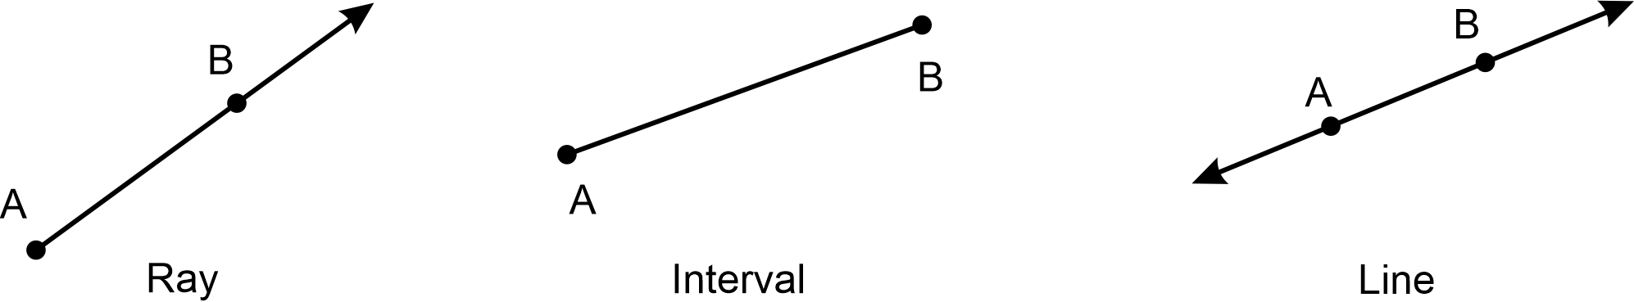
Image long description: The first diagram is a ray starting at point A and continuing through point B. The second diagram shows an interval of a line starting at point A and ending at point B. The third shows a line that goes through points A and B and continues through both.

- Identify and label the vertex and arms of an angle with capital letters
- Use appropriate conventions to label and name angles
Example(s):
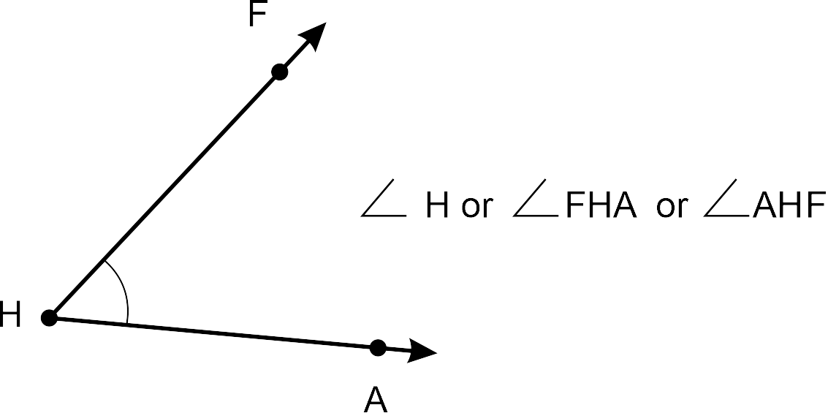

- Use common conventions to indicate right angles, equal angles and intervals on diagrams
Example(s):
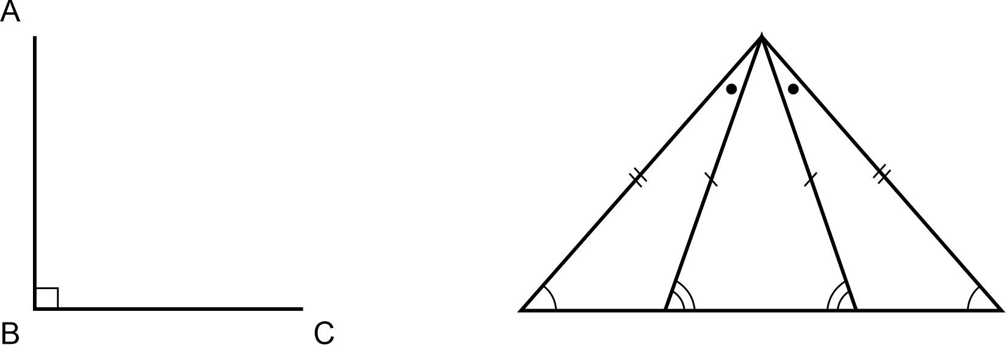
Image long description: The first diagram is a right angle through the points ABC. The second diagram has one isosceles triangle inside another isosceles triangle showing equal sides and equal base angles.

Identify geometrical properties of angles at a point
- Identify right angles, straight angles, angles of complete revolution and vertically opposite angles
UuM8
- Apply the terms complementary and supplementary to a pair of angles adding to $$90°$$and $$180°$$, respectively
Example(s):
Identifying complementary and supplementary angles arising from right angles and straight angles. $$∠ABC$$ and $$∠CBD$$ are complementary since $$∠ABD$$ is a right angle. $$∠FHG$$ and $$∠JHG$$ are supplementary since $$∠FHJ$$ is a straight angle.
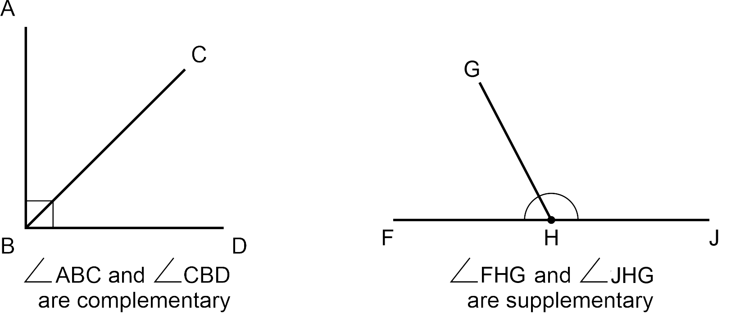
Image long description: The first diagram shows right angle ABD dissected by line BC forming complementary angles. The second diagram shows straight angle FHJ with line GH in the middle at a diagonal forming supplementary angles.
UGP5
- Apply the term adjacent angles to a pair of angles with a common arm and common vertex
Example(s):
$$∠ADC$$ is adjacent to $$∠BDC$$ and reflex $$∠ADB$$.
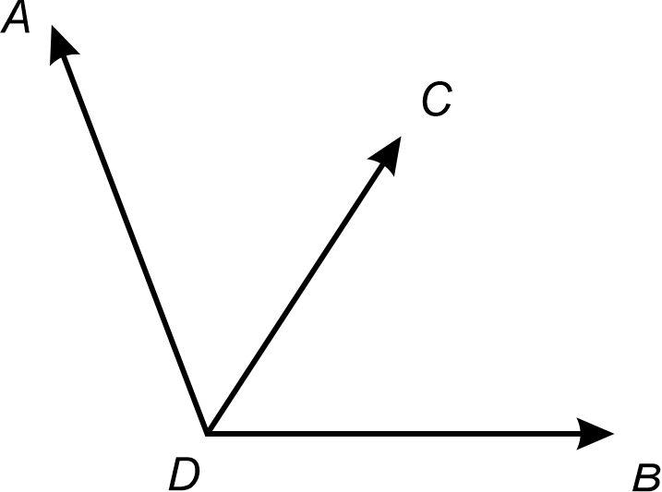

Identify and describe corresponding, alternate and co-interior angles when 2 straight lines are crossed by a transversal, including parallel lines
- Identify and describe perpendicular lines using the symbol for is perpendicular to ($$⊥$$)
UuM8, UGP6
- Apply the common conventions to indicate parallel lines on diagrams
Example(s):
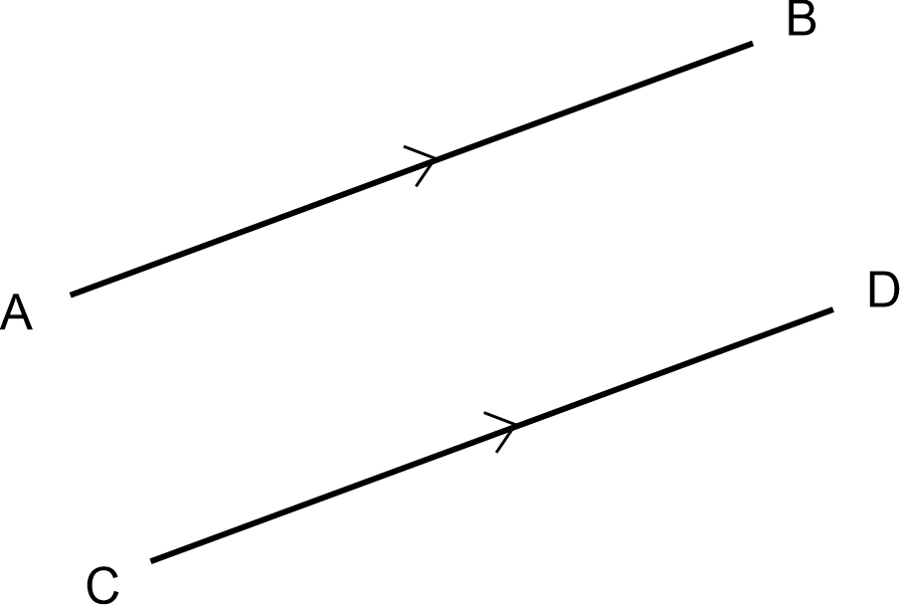

- Identify and describe pairs of parallel lines using the symbol for is parallel to ($$∥$$)
UGP6
- Identify and define transversals, including transversals of parallel lines
Example(s):
Transversal XY cuts the lines AB and CD at Z and W.
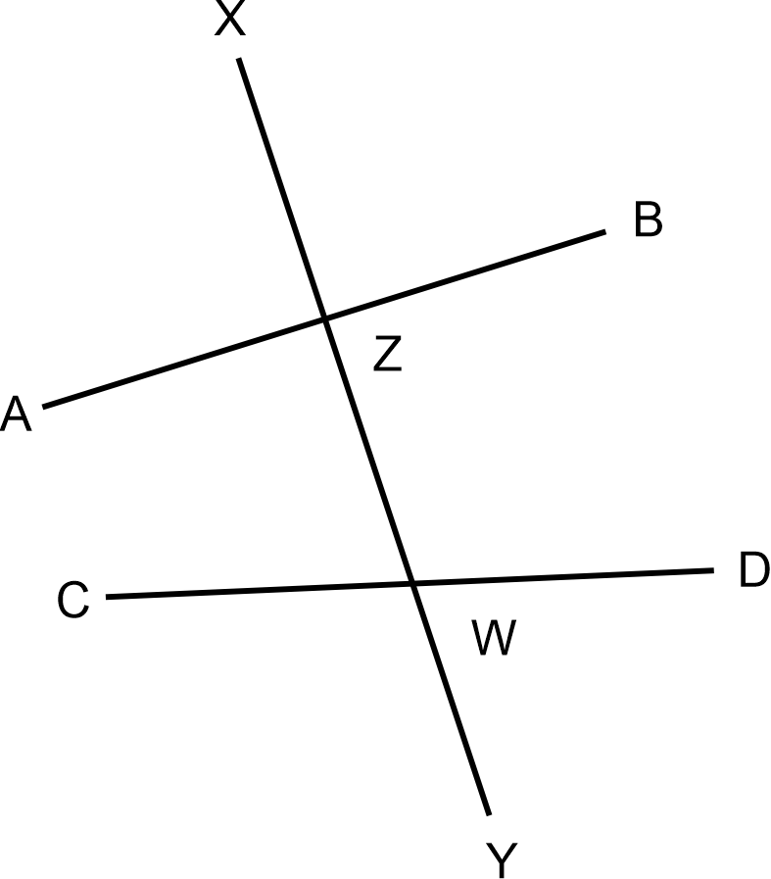

- Identify, name and measure alternate angle pairs, corresponding angle pairs and co-interior angle pairs for 2 lines cut by a transversal
Example(s):
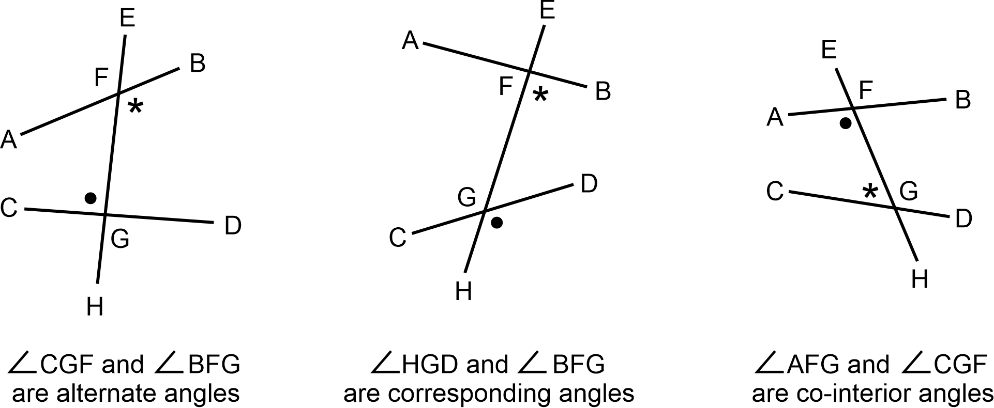
UGP6
- Verify and identify corresponding angles and alternate angles as equal, and co-interior angles as supplementary, when a pair of parallel lines is cut by a transversal
Example(s):
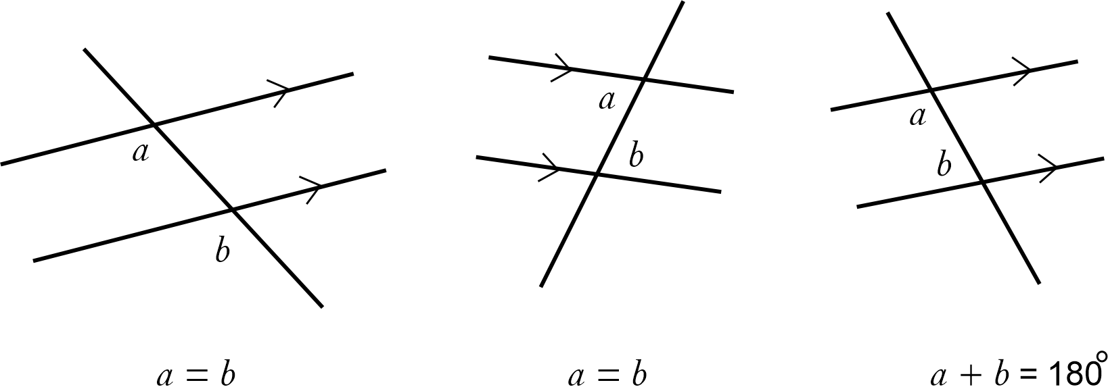
Image long description: A corresponding angle and alternate interior angles where angle a and angle b are equal. A co-interior angle where angle a plus angle b equals 180 degrees.
UGP6
- Justify that 2 lines are parallel by using properties of alternate, corresponding or co-interior angles on parallel lines
UGP6

Solve numerical problems involving angles using reasoning
- Apply the knowledge of angle relationships including angles at a point to find the sizes of unknown angles embedded in diagrams and give reasons
Example(s):
Finding the size of the unknown angle and give reasons:
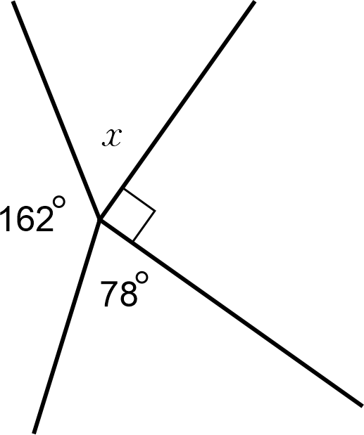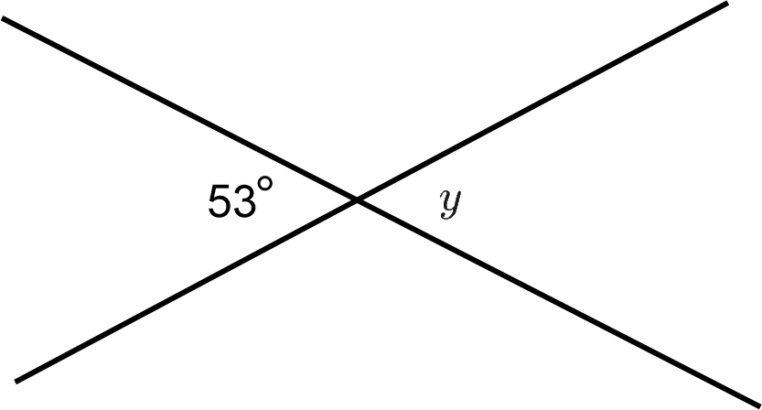
$$x+162°+90°+78°=360°$$ (angles at a point)
$$∴x=30°$$
$$y=53°$$ (vertically opposite angles)
UGP5, NPA6
- Apply the knowledge of angles associated with parallel lines to find the sizes of unknown angles embedded in related diagrams and give reasons
Example(s):
If $$∠BCH=114°$$, find the size of $$∠ABF$$ and $$∠EBC$$ and give reasons.
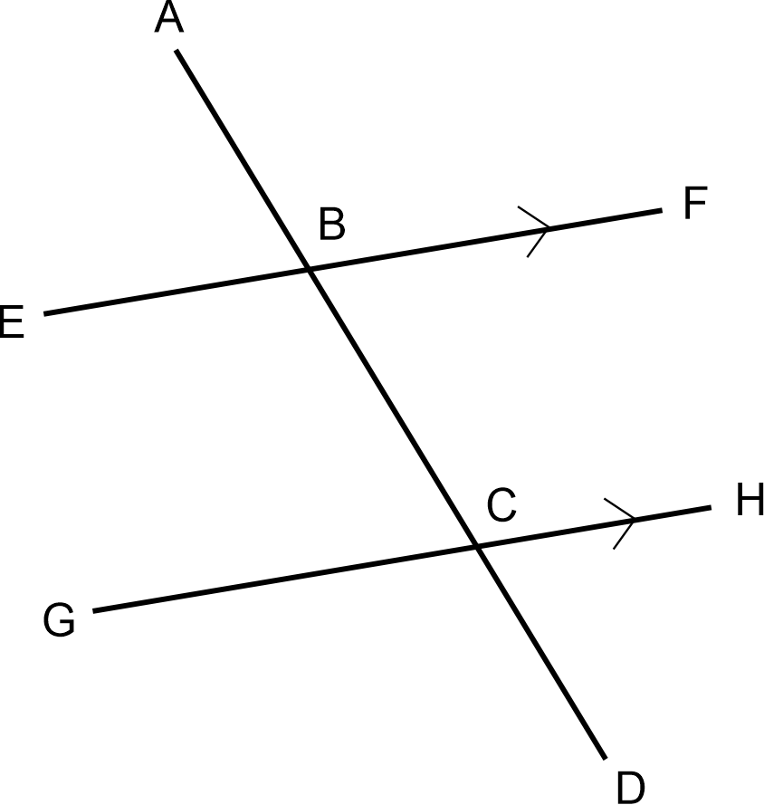
Finding the value of $$x$$ in the diagram below and give reasons:
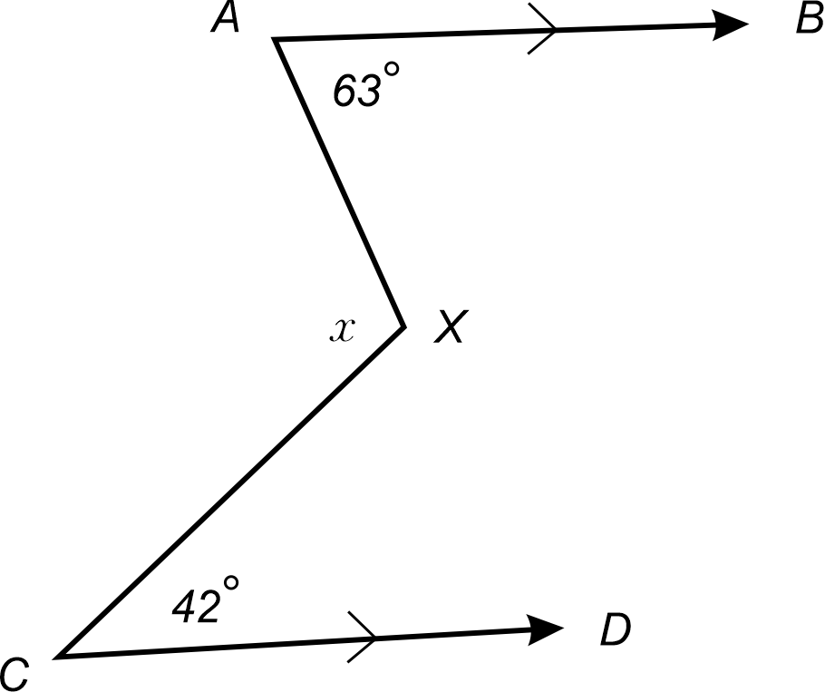
Construct a line $$XY$$ through $$X$$ parallel to $$AB$$ and $$CD$$.
$${63}^{°}+∠AXY={180}^{°}$$ (co-interior angles, $$AB∥XY$$)
$$∴∠AXY={117}^{°}$$
Similarly, $$∠YXC+{42}^{°}={180}^{°}$$
$$∴∠YXC={138}^{°}$$
$$x+{117}^{°}+{138}^{°}={360}^{°}$$ (angles at a point)
$$∴x={105}^{°}$$
UGP6, NPA6

Properties of geometrical figures

Outcomes
A student:
- develops understanding and fluency in mathematics through exploring and connecting mathematical concepts, choosing and applying mathematical techniques to solve problems, and communicating their thinking and reasoning coherently and clearly MAO-WM-01
- identifies and applies the properties of triangles and quadrilaterals to solve problems MA4-GEO-C-01
Related Life Skills outcomes: MALS-GEO-01

Content

Classify triangles according to their side and angle properties
- Label triangles using appropriate text and symbols
Example(s):
Triangle $$ABC$$ can be written as $$△ABC$$.

- Classify and describe types of triangles based on their properties, including acute-angled, right-angled, obtuse-angled, equilateral, isosceles and scalene triangles
Example(s):
Recognising that a given triangle may belong to more than one class such as right-angled scalene triangles and obtuse-angled isosceles triangles.
UGP6

Classify quadrilaterals and describe their properties
- Identify quadrilaterals using naming conventions
Example(s):
Recognising that quadrilateral ABCD is the same as ADCB but not the same as ACBD.
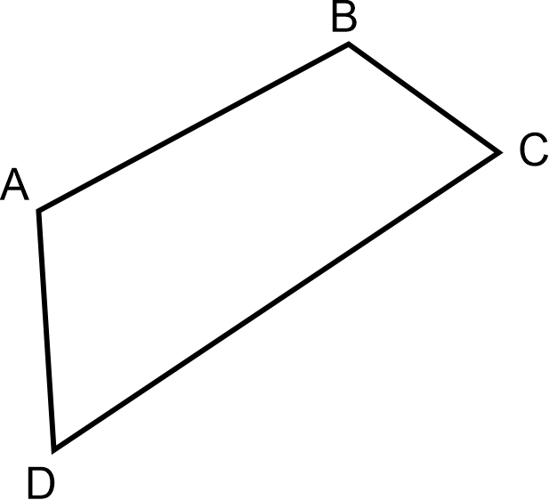
UGP4
- Distinguish between convex and non-convex quadrilaterals
Example(s):
Non-convex (also called concave) quadrilaterals have one internal reflex angle.
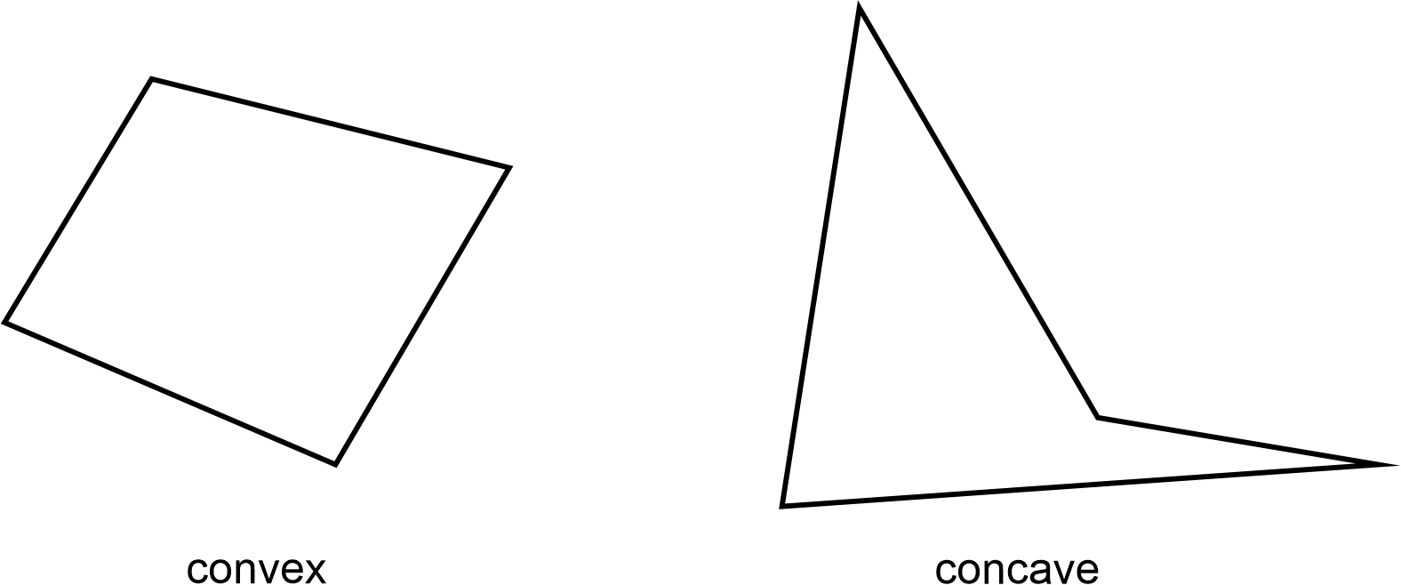
UGP4
- Verify and describe the properties of the special quadrilaterals which include parallelograms, rectangles, rhombuses, squares, trapeziums and kites
Example(s):
Properties of special quadrilaterals:
Opposite sides are parallel.
Opposite sides are equal.
Adjacent sides are perpendicular.
Opposite angles are equal.
Diagonals are equal.
Diagonals bisect each other.
Diagonals bisect each other at right angles.
Diagonals bisect the angles of the quadrilateral.
UGP4
- Identify and label the properties of the special quadrilaterals using appropriate conventions
UGP4
- Classify quadrilaterals based on their properties
UGP4
- Justify why some quadrilaterals may be classified as more than one type of quadrilateral
UGP4

Apply the properties of triangles and quadrilaterals
- Prove that the interior angle sum of a triangle is 180° with or without digital tools
Example(s):
Proving the interior angle sum of a triangle is 180°:
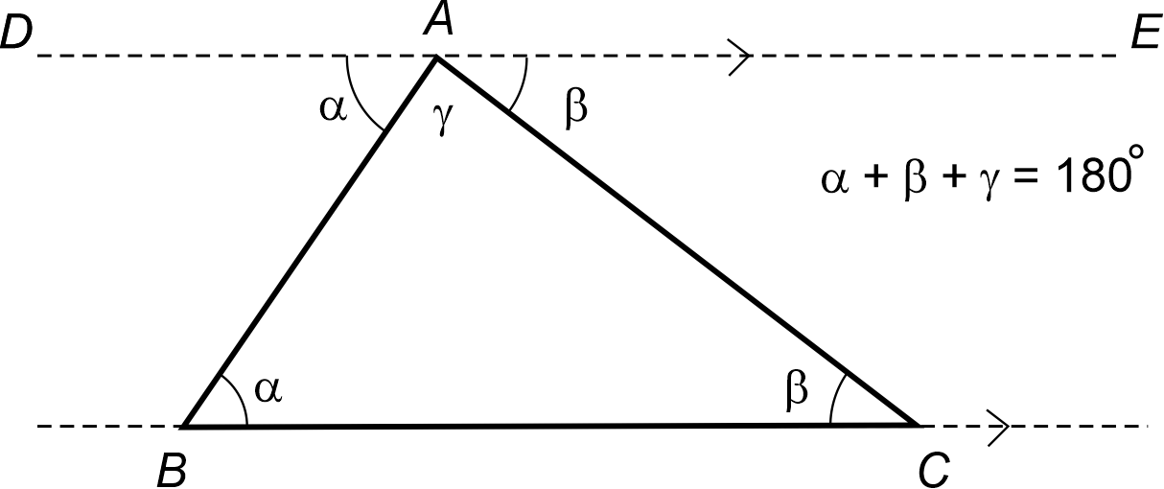
Construct $$DE$$ parallel to $$BC$$.
$$∠DAB=∠ABC=α$$ (alternate angles, $$DE∥BC$$)
$$∠EAC=∠BCA=β$$ (alternate angles, $$DE∥BC$$)
$$α+β+γ={180}^{°}$$ (straight angle)
$$∴∠ABC+∠BCA+∠CAB={180}^{°}$$
Image long description: Triangle ABC with interior angles alpha, beta and gamma. Line DE is constructed parallel to BC at point A forming a straight angle of alpha, gamma and beta with a sum of 180 degrees.
UGP6
- Prove that any exterior angle of a triangle equals the sum of the 2 interior opposite angles
UGP6
- Apply the angle sum of a triangle to prove that the angle sum of a quadrilateral is 360°
UGP6
- Apply the properties of triangles and quadrilaterals to determine unknown sides and angles to solve problems, giving reasons
Example(s):
Finding the value of $$x$$ given $$PQRS$$ is a parallelogram:
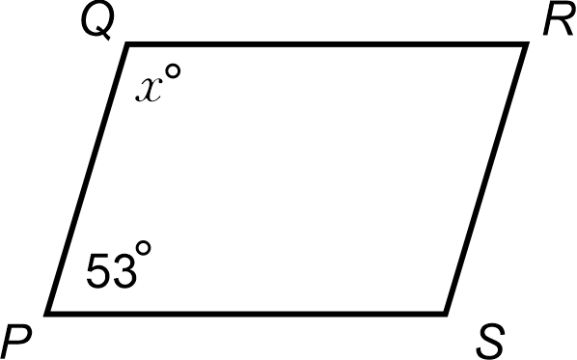
$$QR∥PS$$ (opposite sides of a parallelogram are parallel)
$$x+{53}^{°}={180}^{°}$$ (co-interior angles are supplementary, $$QR∥PS$$)
$$∴x={127}^{°}$$
UGP6, NPA6

Data classification and visualisation

Outcomes
A student:
- develops understanding and fluency in mathematics through exploring and connecting mathematical concepts, choosing and applying mathematical techniques to solve problems, and communicating their thinking and reasoning coherently and clearly MAO-WM-01
- classifies and displays data using a variety of graphical representations MA4-DAT-C-01
Related Life Skills outcomes: MALS-DAT-01

Content

Classify data as either numerical (discrete or continuous) or categorical (nominal or ordinal) variables
- Define a variable in the context of statistics as any characteristic, number or quantity that can be measured or counted
- Classify and describe variables as numerical or categorical
- Describe a numerical variable as either discrete or continuous
Example(s):
Discrete (number of students, shoe size) and continuous (height, weight).
IRD4
- Describe a categorical variable as nominal or ordinal
Example(s):
Nominal (blue, green, yellow) and ordinal (small, medium, large).
IRD3
- Distinguish between and compare numerical (discrete or continuous) and categorical (nominal or ordinal) variables
IRD4

Display data using graphical representations relevant to the purpose of the data
- Represent single datasets using graphs, including frequency histograms and polygons, dot plots, stem-and-leaf plots, divided bar graphs, column graphs, line graphs, sector graphs and pictograms, with or without digital tools
Example(s):
Using data from various sources, examine population characteristics of Aboriginal and/or Torres Strait Islander Peoples across all states and territories. Use various data representations to highlight changes over time.
IRD3, IRD4
- Include sources, titles, labels and scales when displaying data in a graph
Example(s):
The source indicates where the data was collected, the title introduces the data in the graph, the labels identify each axis and scales identify the possible values of a variable along an axis.
IRD3, IRD4
- Select the type of graph best suited to represent various single datasets and justify the choice of graph
Example(s):
Comparing the characteristics of histograms and column graphs and justifying their use for datasets.
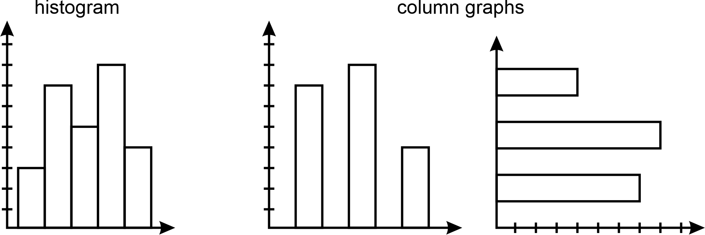
Image long description: A histogram graph with dashes along the vertical axis and the bars close together. 2 column graphs, one with dashes along the vertical axis and another with dashes along the horizontal axis. The bars follow the direction of the dashes and have spaces between them.
IRD3, IRD4
- Represent a dataset using a statistical infographic and justify the choice of graphical representation used
Example(s):
Creating a statistical infographic showing information about Aboriginal and/or Torres Strait Islander Peoples. Information could include data from the most recent census indicating changes over time in the Aboriginal and Torres Strait Islander population.
Using a statistical infographic to enhance retention and recall of information through visually compelling charts.
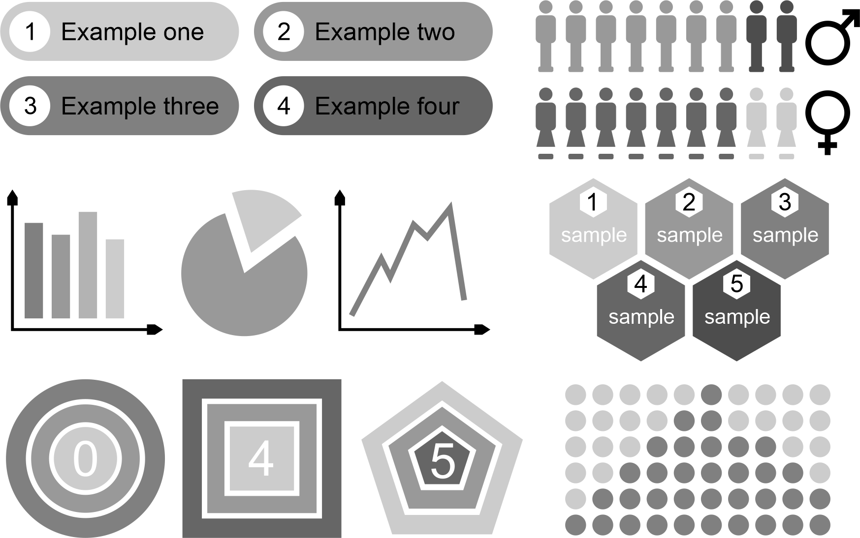
IRD6

Interpret data in graphical representations
- Identify and interpret data displayed on graphs
Example(s):
Identifying variables from a histogram, dot plot, stem-and-leaf plot, bar graph, line graph, sector graph and pictogram, interpret the data.
IRD3, IRD4
- Identify features of graphical representations to draw conclusions
IRD6
- Interpret patterns in graphical representations to make predictions
IRD6
- Explain why a given graphical representation can lead to a misinterpretation of data
Example(s):
Examining the graphical representation of the cost of services over many years and concluding that the increase in cost of services in Year 4 is much greater than that in Year 3 due to a larger prism.
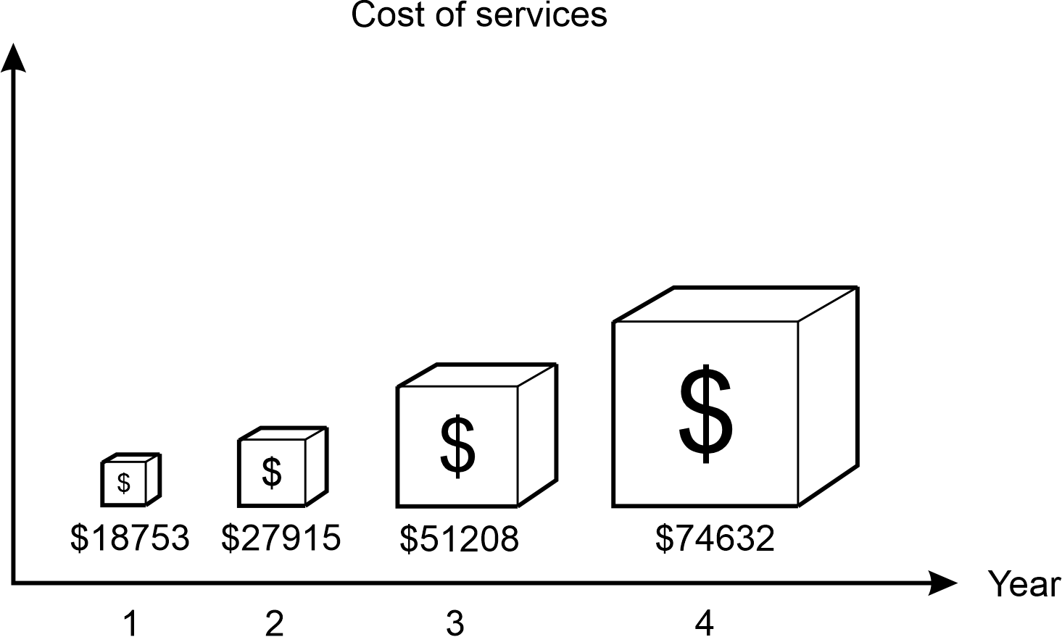
Image long description: Example of a misleading graph depicting cost of services plotted against time in years. Three-dimensional columns have non-uniform values and continue to increase in size as time progresses.
IRD4

Data analysis

Outcomes
A student:
- develops understanding and fluency in mathematics through exploring and connecting mathematical concepts, choosing and applying mathematical techniques to solve problems, and communicating their thinking and reasoning coherently and clearly MAO-WM-01
- analyses simple datasets using measures of centre, range and shape of the data MA4-DAT-C-02
Related Life Skills outcomes: MALS-DAT-02

Content

Calculate and compare the mean, median, mode and range for simple datasets
- Calculate the mean $$(\overset{‾}{x})$$ of a set of data using digital tools
Example(s):
Using the statistical functions of a spreadsheet or another digital tool to determine the mean for both small and large datasets.
IRD5
- Calculate and describe the mean, median, mode and range of a dataset
IRD5
- Classify the mean, median and/or mode as measure(s) of centre to represent the average or typical value of a dataset
IRD5
- Describe and interpret data displays using mean, median and range
Example(s):
Calculating measures of centre and range and using these to describe and interpret data represented in a variety of statistical displays, including frequency distribution tables, histograms, stem-and-leaf plots and dot plots.
IRD5
- Identify and describe datasets as having no modes (uniform), one mode (unimodal), 2 modes (bimodal) or multiple modes (multimodal)
Example(s):
Identifying which of the following diagrams is closest to a uniform distribution:


- Identify the range as a measure of spread to describe variation in a dataset
IRD5
- Compare simple datasets using the mean, median, mode and range
IRD5

Interpret the effect individual data points have on measures of centre and range
- Informally identify clusters, gaps and outliers in datasets and give reasons for their occurrence in the context of the data
Example(s):
Identifying and describing outliers informally from statistical displays and exploring the reasons why these might occur.
IRD6
- Identify and explain the impact of adding or removing data values that are clustered at one end of a dataset on the measures of centre
Example(s):
Justifying why adding a score of 12 to the set of scores 2, 3, 4, 5, 5, 5, 6, 8 will not change the mode of 5.
Explaining the effect on the mean if a score of 99% is added to a set of 20 test scores with an average of 60%.
IRD6
- Identify and explain the impact of outliers on the measures of centre and range
Example(s):
Analysing why it is more appropriate to use the median than the mean when the data contains one or more outliers.
IRD6
- Determine and justify the most appropriate measure of centre to summarise the data in its context
Example(s):
Using the median as the appropriate measure of centre to determine the average house price in a suburb to avoid distortion of the data by outliers. Using the mean to determine the average test score in a mathematics test when most of the marks are close together.
IRD6

Analyse datasets presented in various ways and draw conclusions
- Identify and describe the shape and distribution of a dataset using the terms symmetrical, negatively skewed and positively skewed
Example(s):
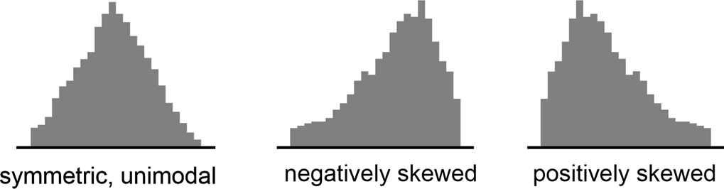

- Define a census as a study of every unit, everyone or everything in a population
- Define a sample as a subset of units in a population selected to represent all units in a population of interest
IRD7
- Draw conclusions and make informed decisions about data gathered using data-collection techniques, including census and sampling, which is then presented in tables, graphs and charts
Example(s):
Identifying and describing factors that may have masked results, analysing the accuracy of measurements taken, and determining whether the outcomes of the study can be generalised to other situations.
IRD6, IRD7

Probability

Outcomes
A student:
- develops understanding and fluency in mathematics through exploring and connecting mathematical concepts, choosing and applying mathematical techniques to solve problems, and communicating their thinking and reasoning coherently and clearly MAO-WM-01
- solves problems involving the probabilities of simple chance experiments MA4-PRO-C-01
Related Life Skills outcomes: MALS-PRO-01

Content

Determine probabilities for chance experiments
- List the sample space for chance experiments
Example(s):
Explaining that if a standard 6-sided die is rolled once, the sample space (S) is S = {1, 2, 3, 4, 5, 6}.
Explaining that the sample space for a spinner with 6 equal segments, 2 of which are red, 3 are green and 1 is white is $$S=\left\{R, G, W\right\}$$.

- Express the probability of an event, which has a finite number of equally likely outcomes, as $$P\left(event\right)=\frac{number of favourable outcomes}{total number of outcomes}$$
Example(s):
Representing the probability of rolling a 4 on a 6-sided die as $$P\left(4\right)=\frac{1}{6}$$.
The probability of landing on green using a spinner with 6 equal segments, 2 of which are red, 3 are green and 1 is white is $$P\left(\text{G}\right)=\frac{3}{6}$$.

- Recognise that probabilities range from 0 (impossible) to 1 (certain) and that equally likely outcomes have equal probabilities
- Verify that the total of the probabilities of all possible outcomes of an event is 1
UnC5
- Identify and describe theoretical (expected) probabilities as being the likelihood of outcomes occurring under fair or unbiased conditions
- Explain that observed probability is the relative frequency resulting from repeated trials of a simulation and determine observed probabilities
Example(s):
Inferring that if a 6 appears on the uppermost face of a die 30 times when a die is rolled 120 times, the observed probability of a 6 is $$\frac{30}{120}=\frac{1}{4}$$.
UnC5
- Explore relative frequencies by using a random number generator to repeat a chance experiment a number of times
UnC5

Determine probabilities for complementary events
- Identify and describe the complement of an event
Example(s):
Explaining that the complement of rolling a 3 on a die is not rolling a 3 on a die.
UnC5
- Verify that the sum of the probability of an event and its complement is a total of 1
Example(s):
Verifying that since the probability of rolling a 3 on a die is $$\frac{1}{6}$$and the probability of not rolling a 3 on a die is $$\frac{5}{6}$$, then the sum of the event and its complement is 1.
UnC5
- Solve problems involving the probability of complementary events
UnC5
- Represent the possible outcomes for complementary events in various forms

Assessment
The primary role of assessment is to establish where students are in their learning so that teaching can be differentiated and further learning progress can be monitored over time. It provides information that assists teachers to target their teaching at the point of student need. Assessment is most effective when it is an integral part of teaching and learning programs.
Assessment involves:
- establishing where students are in their learning
- ongoing monitoring
- formative and summative tasks
- providing feedback about student progress.

Common Grade Scale
Stage 1, Stage 2, Stage 3, Stage 4, Stage 5
The common grade scale can be used to report student achievement in both primary and junior secondary years in all NSW schools.

Course performance descriptors
Stage 5 – Year 10
Course performance descriptors provide holistic descriptions of typical achievement at different grade levels in a specific course. They are used to identify and report a student’s level of achievement in a Board Developed Course at the end of Stage 5.

Grade A
A student performing at this grade typically:
- demonstrates extensive understanding of the relationships between mathematical concepts
- uses, creates and interchangeably moves between a variety of abstract and concrete representations in familiar and unfamiliar situations
- solves routine problems involving multiple steps consistently in familiar and unfamiliar situations
- uses multiple connections between concepts to solve non-routine problems
- applies deductive reasoning and concise, formal mathematical arguments to prove and justify results in a variety of forms
- uses precise mathematical language consistently and effectively to communicate reasoning, explain solutions and justify results

Grade B
A student performing at this grade typically:
- demonstrates thorough understanding of the relationships between mathematical concepts
- uses, creates and moves between abstract and concrete representations in familiar and unfamiliar situations
- solves routine problems of up to 3 steps in familiar and unfamiliar situations and attempts routine problems of more than 3 steps with some success
- uses some connections between concepts to attempt non-routine problems
- applies formal and informal mathematical reasoning to prove and justify results
- uses appropriate mathematical language effectively to communicate reasoning, explain solutions and justify results

Grade C
A student performing at this grade typically:
- demonstrates sound understanding of the relationships between mathematical concepts
- uses and creates abstract or concrete representations in familiar situations
- solves routine problems of up to 3 steps in familiar situations and attempts routine problems of more than 3 steps
- identifies some connections between concepts when attempting non-routine problems
- uses informal mathematical reasoning to prove or justify results
- uses mathematical language to communicate reasoning and explain solutions

Grade D
A student performing at this grade typically:
- identifies some relationships between mathematical concepts
- uses concrete representations in some familiar situations
- attempts routine problems of up to 3 steps with some success
- uses informal mathematical reasoning
- uses limited mathematical language

Grade E
A student performing at this grade typically:
- recognises some mathematical concepts
- attempts some routine problems with very limited success
- attempts to use informal mathematical reasoning
- uses very limited mathematical language

Assessment of Life Skills outcomes
Stage 4, Stage 5
The syllabus outcomes and content form the basis of learning opportunities for students. Through the collaborative curriculum planning process, teachers select specific Life Skills outcomes which are based on the needs, strengths, goals, interests and prior learning of each student. Students are required to demonstrate achievement of one or more Life Skills outcomes.
Assessment should provide opportunities for students to demonstrate achievement in relation to the selected outcomes. Assessment can occur in a range of situations or environments such as the school and wider community. Evidence of achievement can be based on:
- formative assessment opportunities
- summative assessment opportunities.
There is no requirement for formal assessment of Life Skills outcomes. Stage 6 Life Skills courses do not have external examinations or mandatory projects.

